

Sales Job Scam Signals
  - Sales job scam signals checklist covering upfront fees, vague company identity, pressure to decide, personal payment asks, too-good pay claims, and no interview substance.
https://accountexecutivejobs.com/blog/sales-job-search/sales-job-red-flags
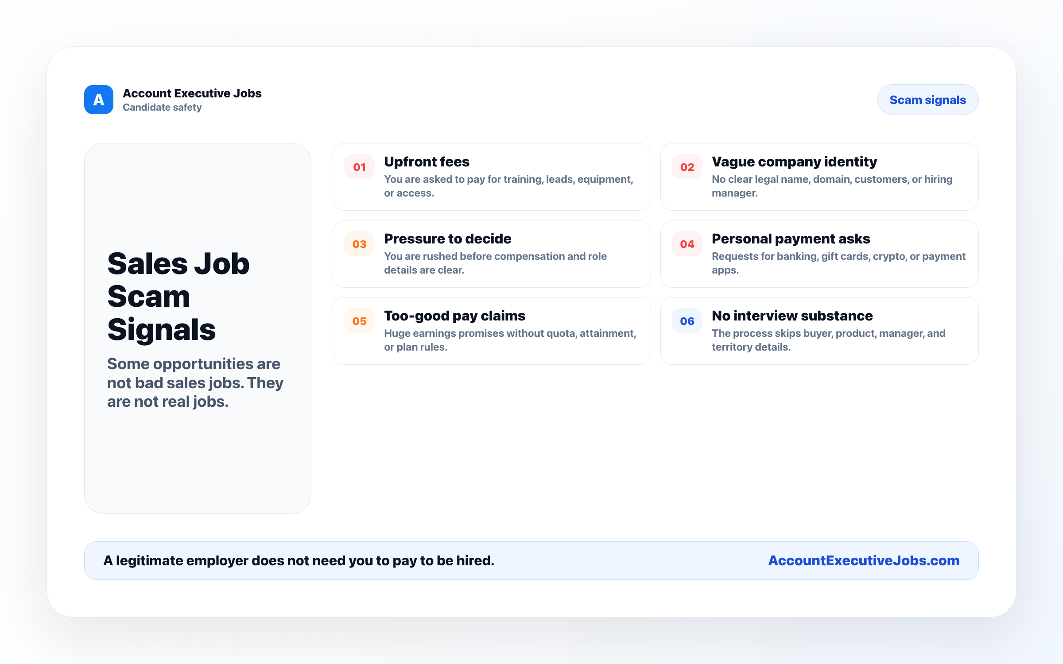

Use this reference
Read the full guide for the context behind this visual. The original illustration and its source belong together when you share it.

Notes

