

OTE Trap Checklist
  - OTE trap checklist for sales jobs covering base split, quota math, ramped attainment, ramp period, payout timing, and clawbacks or caps.
https://accountexecutivejobs.com/blog/sales-job-search/sales-job-red-flags
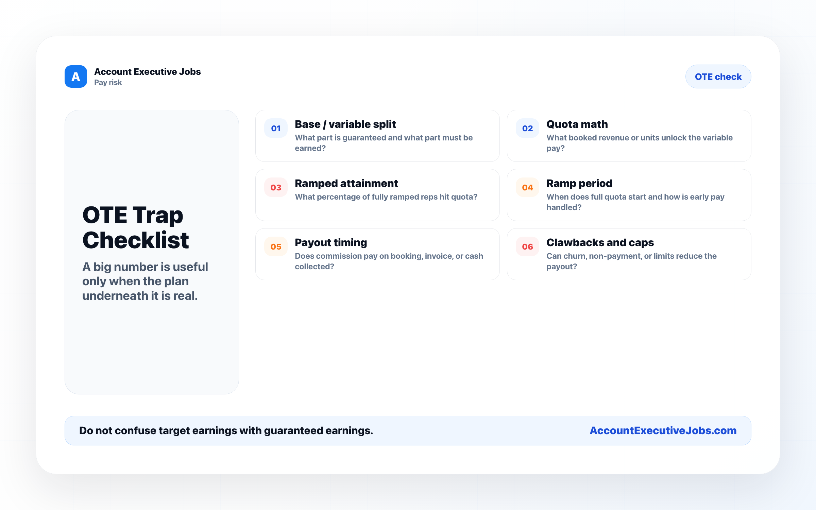

Use this reference
Read the full guide for the context behind this visual. The original illustration and its source belong together when you share it.

Notes

