

Sales Job Offer Review
  - Sales job red flags checklist covering OTE, quota, ramp, territory, manager, commission plan, and team health.
https://accountexecutivejobs.com/blog/sales-job-search/sales-job-red-flags
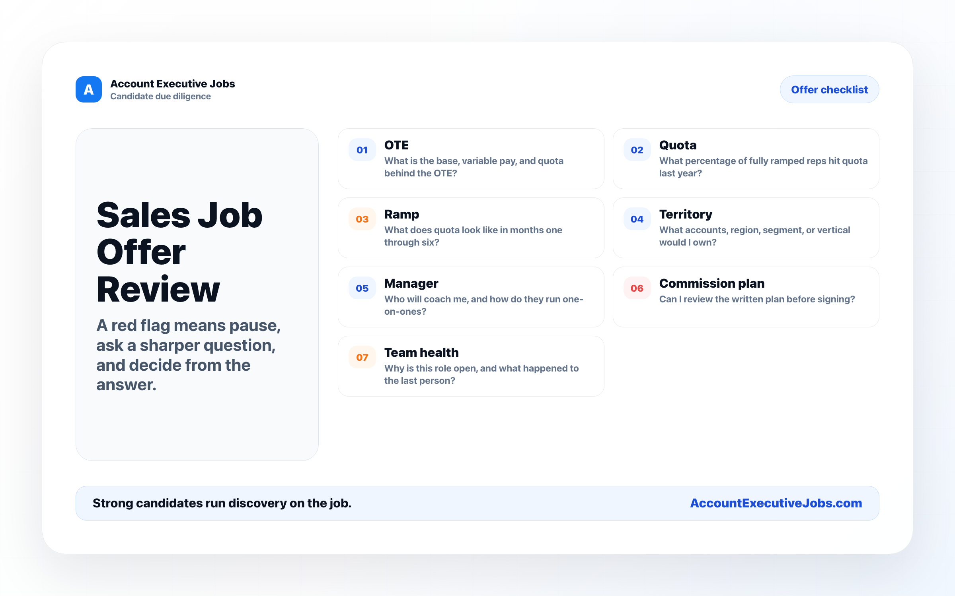

Use this reference
Read the full guide for the context behind this visual. The original illustration and its source belong together when you share it.

Notes

