

Good Answer vs Weak Answer
  - Good answer versus weak answer comparison for sales job red flags.
https://accountexecutivejobs.com/blog/sales-job-search/sales-job-red-flags
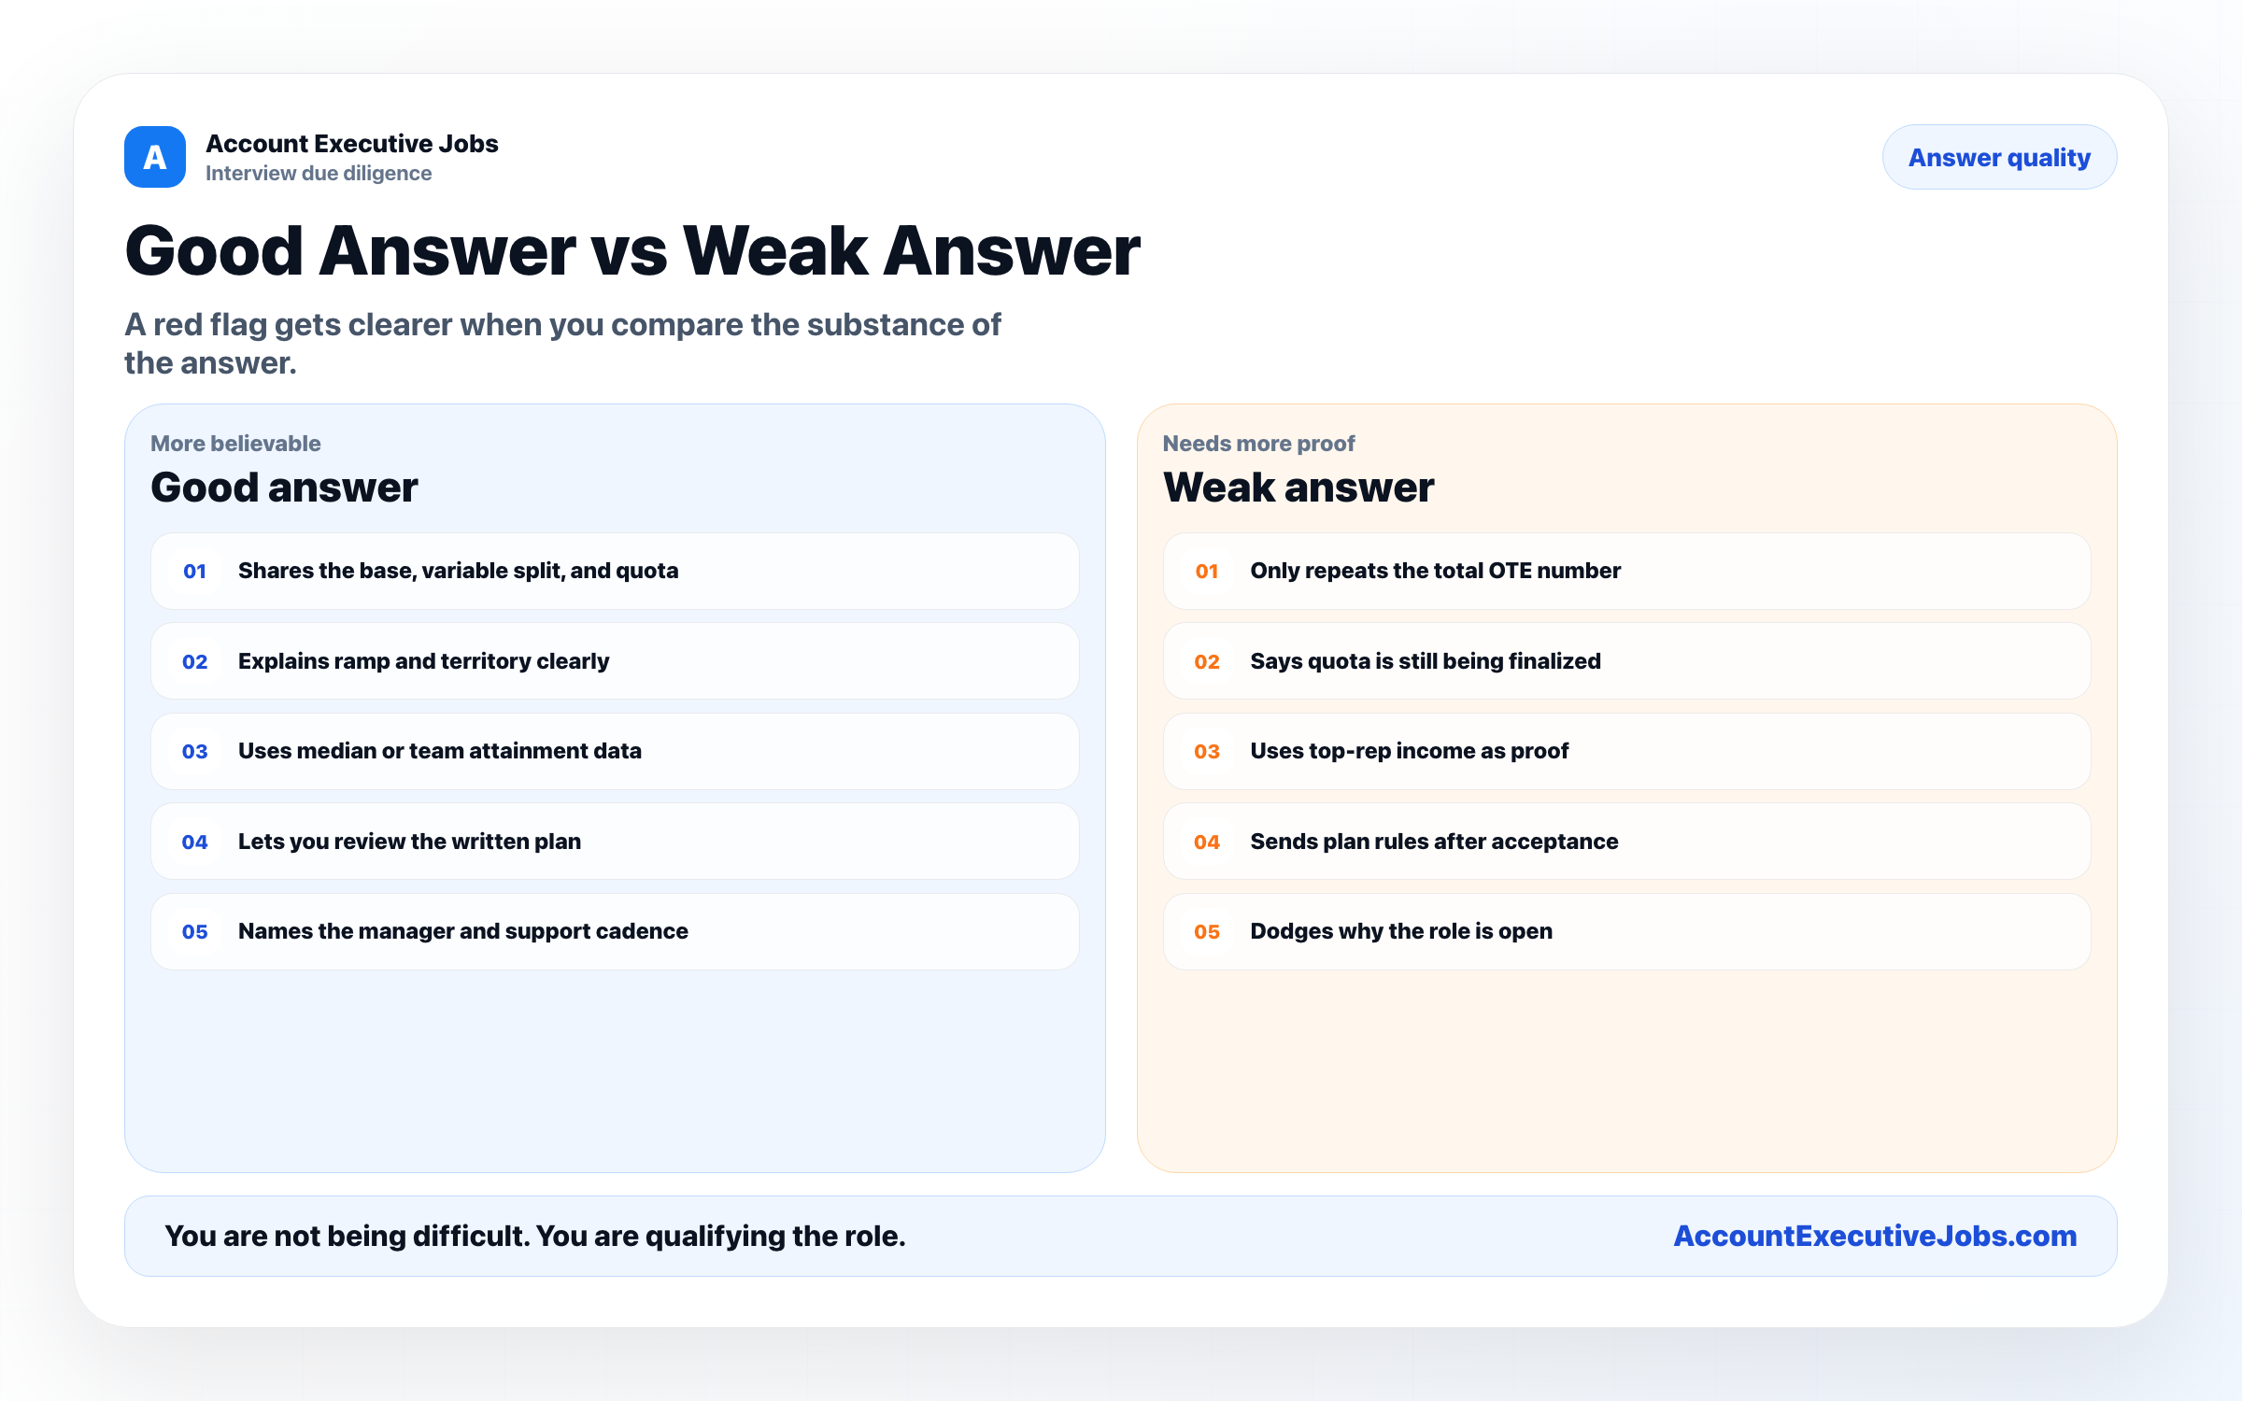

Use this reference
Read the full guide for the context behind this visual. The original illustration and its source belong together when you share it.

Notes

