

Turn Red Flags Into Decisions
  - Animated infographic showing how to turn sales job red flags into decisions by noticing the gap, asking a sharper question, verifying the answer, and deciding whether to continue.
https://accountexecutivejobs.com/blog/sales-job-search/sales-job-red-flags
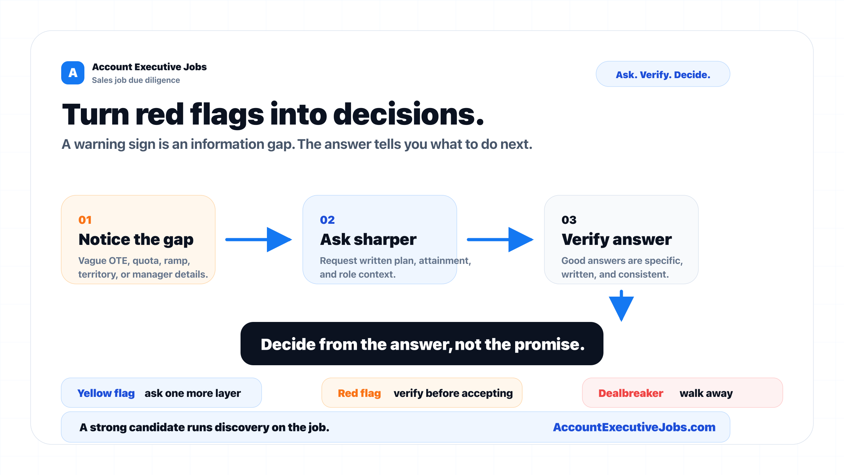

Use this reference
Read the full guide for the context behind this visual. The original illustration and its source belong together when you share it.

Notes

