

What Not To Score
  - What not to score in sales hiring including charisma, logo prestige, culture similarity, confidence, one polished story, and gut feel.
https://accountexecutivejobs.com/blog/hiring-salespeople/sales-hiring-scorecard
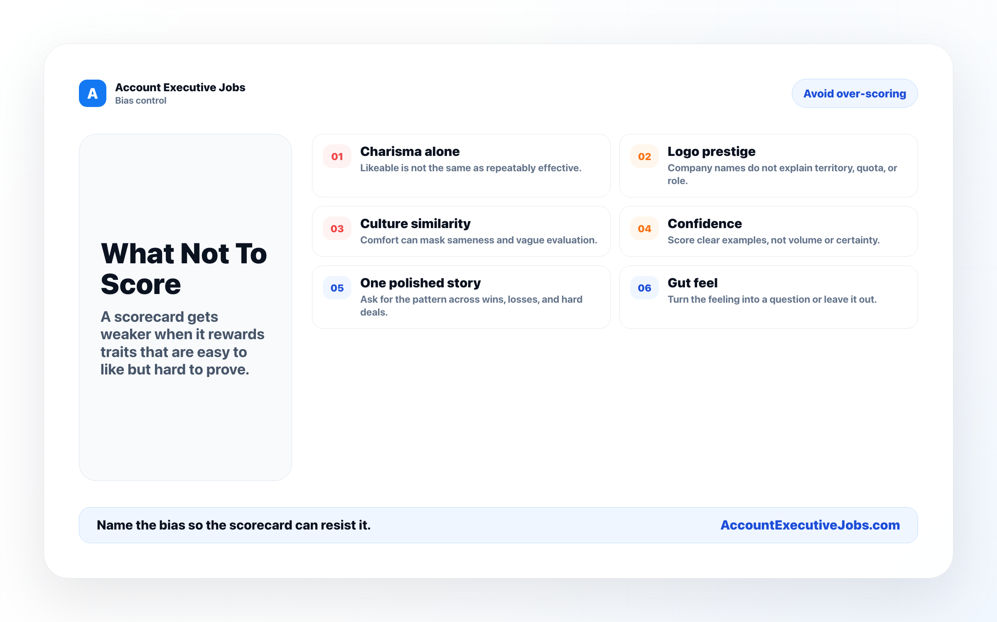

Use this reference
Read the full guide for the context behind this visual. The original illustration and its source belong together when you share it.

Notes

