

Score The Work, Not The Polish
  - Comparison of work evidence versus interview polish for sales hiring scorecards.
https://accountexecutivejobs.com/blog/hiring-salespeople/sales-hiring-scorecard
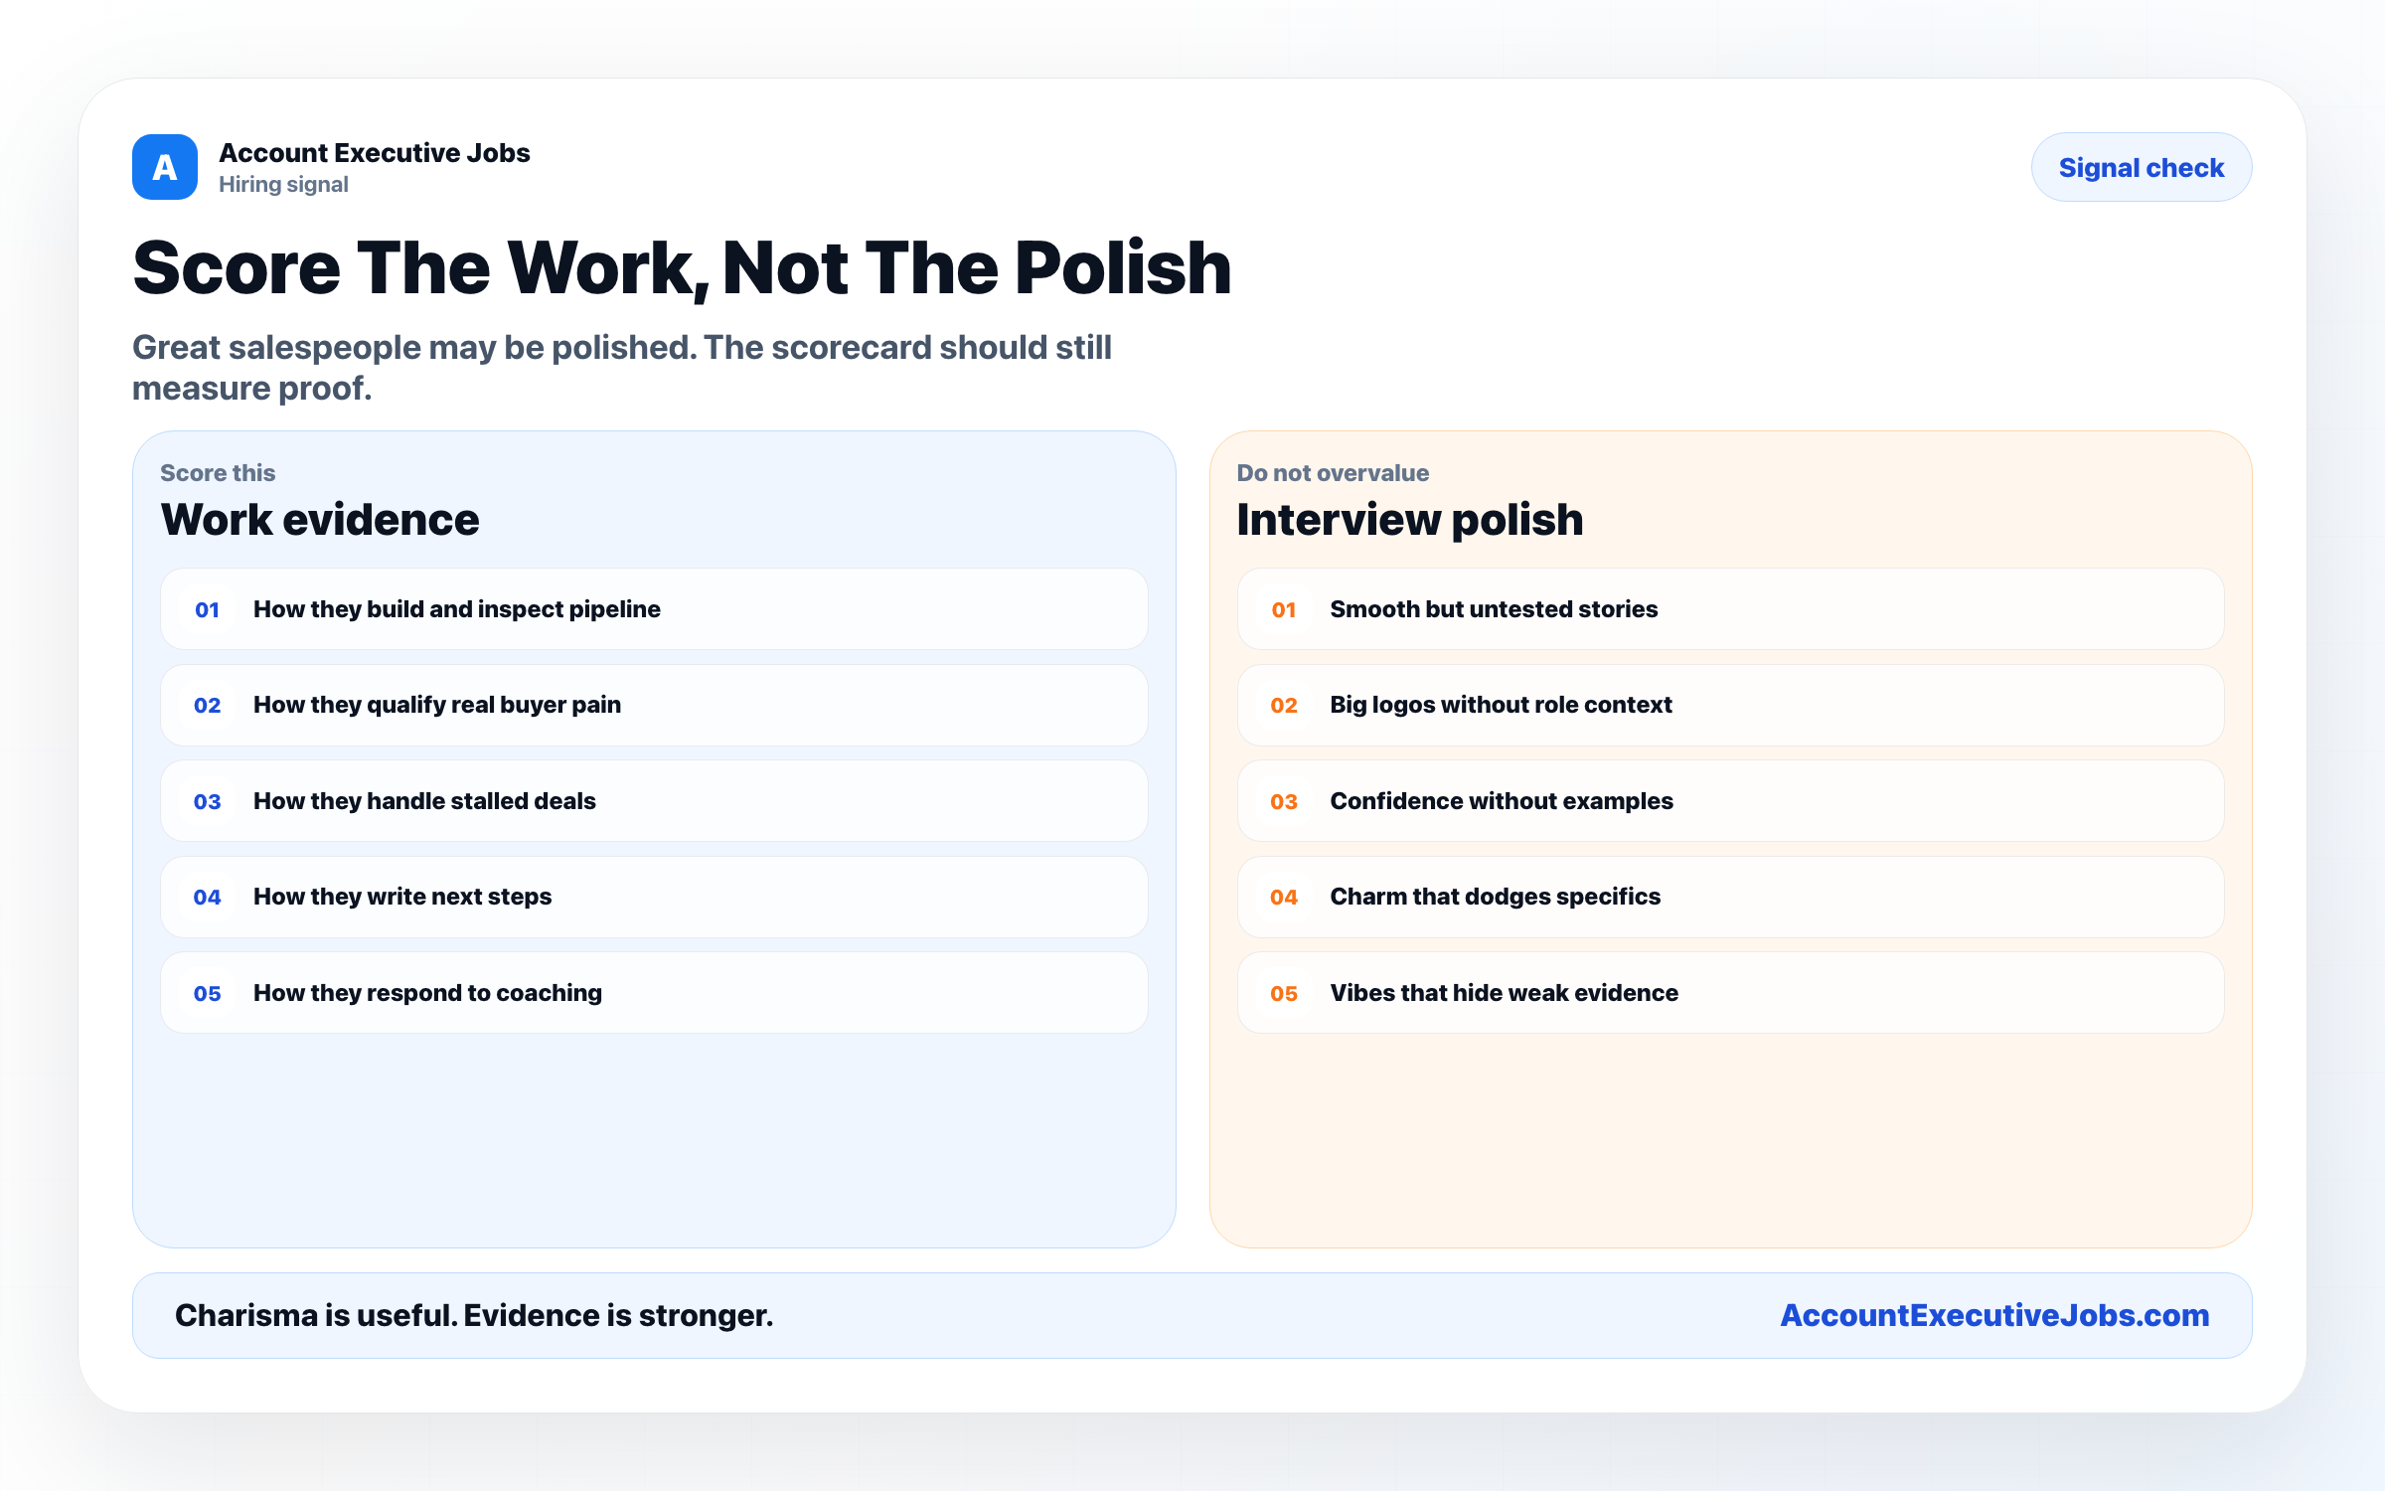

Use this reference
Read the full guide for the context behind this visual. The original illustration and its source belong together when you share it.

Notes

