

Score The Evidence
  - Animated infographic showing a sales hiring scorecard that scores role fit, quota proof, pipeline judgment, discovery quality, deal strategy, and coachability before interview polish.
https://accountexecutivejobs.com/blog/hiring-salespeople/sales-hiring-scorecard
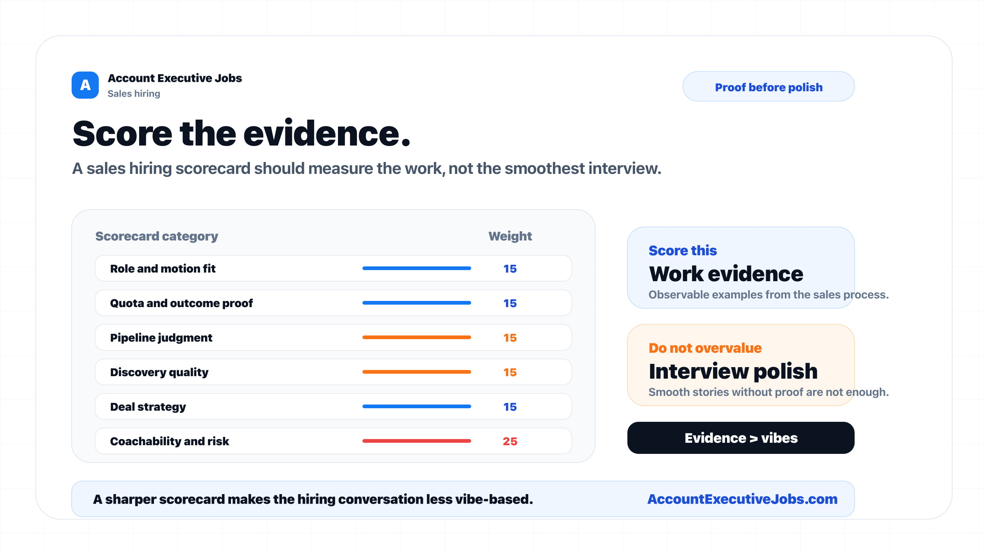

Use this reference
Read the full guide for the context behind this visual. The original illustration and its source belong together when you share it.

Notes

