

Interview Stage Scoring Map
  - Interview stage scoring map for sales hiring covering resume screen, recruiter screen, hiring manager, role-play, panel, and references.
https://accountexecutivejobs.com/blog/hiring-salespeople/sales-hiring-scorecard
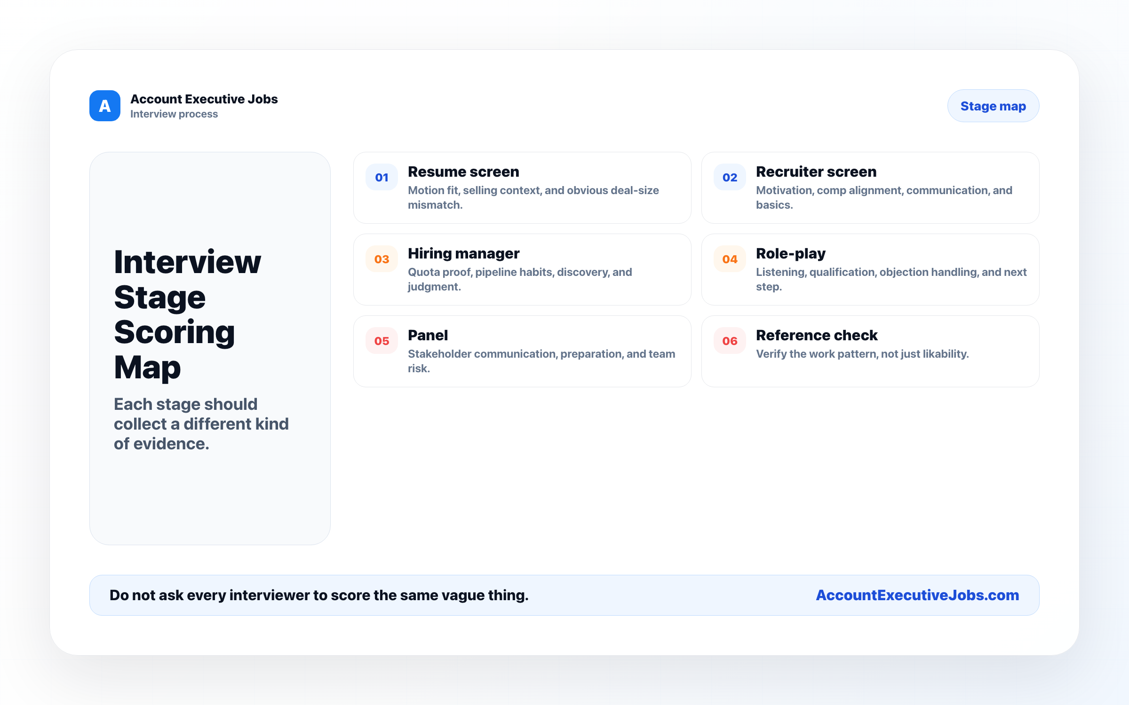

Use this reference
Read the full guide for the context behind this visual. The original illustration and its source belong together when you share it.

Notes

