

Commission Plan Audit
  - Commission plan audit checklist covering credit, thresholds, timing, caps, draws, clawbacks, and written terms.
https://accountexecutivejobs.com/blog/sales-compensation/sales-commission-tiers-cliffs-accelerators
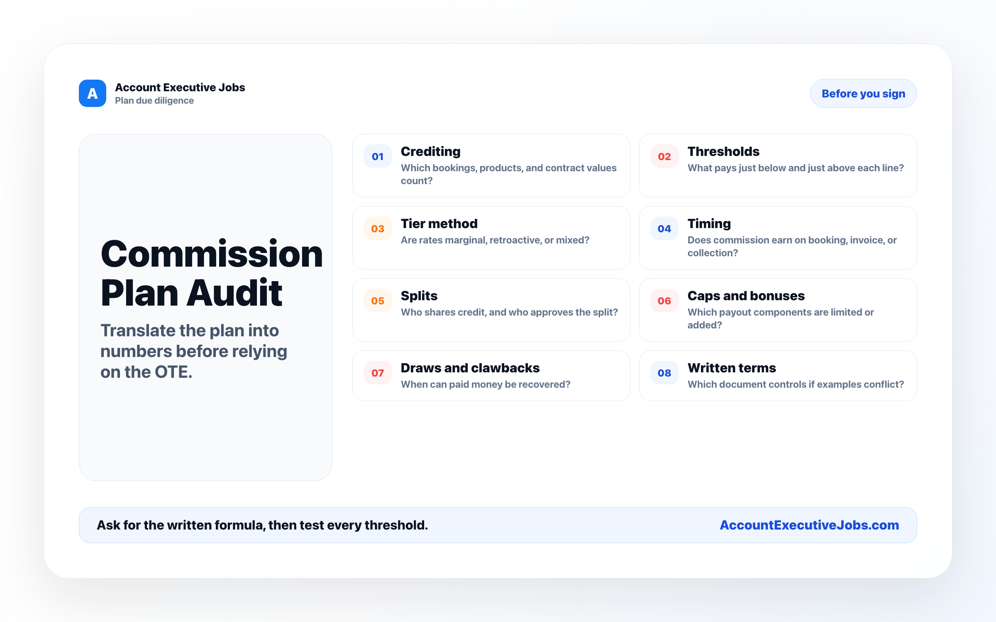

Use this reference
Read the full guide for the context behind this visual. The original illustration and its source belong together when you share it.

Notes

