

From Booked Revenue To Commission
  - Animated sales commission explainer showing booked revenue becoming quota credit, attainment, tiered payout, and net commission.
https://accountexecutivejobs.com/blog/sales-compensation/sales-commission-tiers-cliffs-accelerators
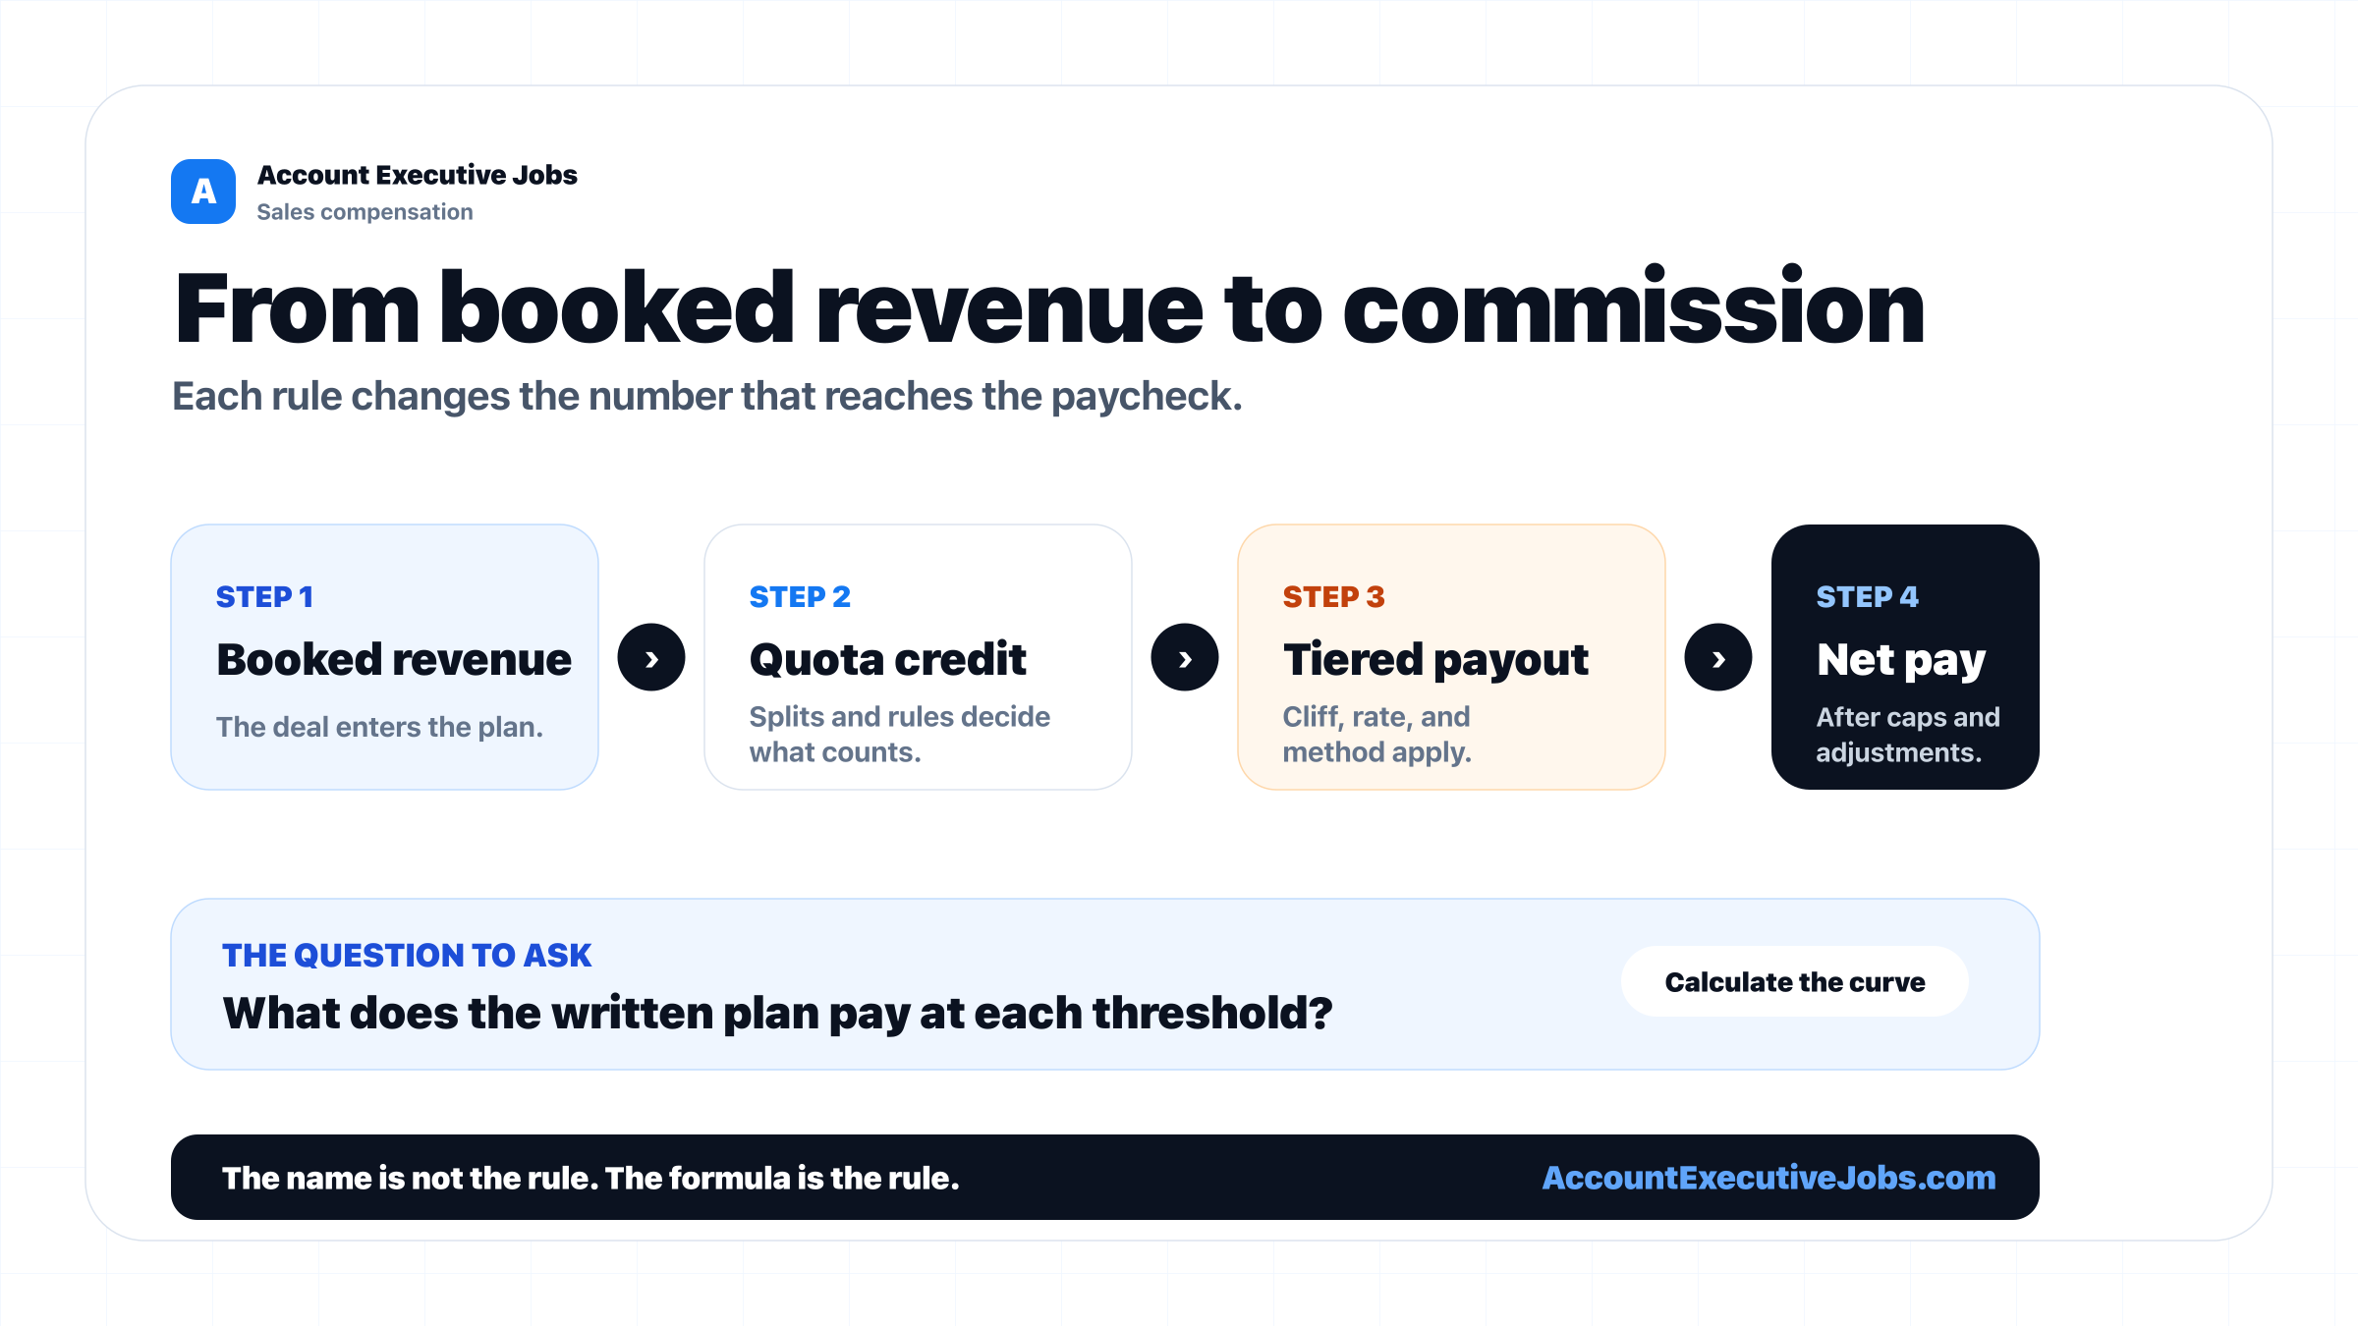

Use this reference
Read the full guide for the context behind this visual. The original illustration and its source belong together when you share it.

Notes

