

Commission Payout Curve
  - Commission payout curve showing how a cliff, decelerator, quota, and accelerator tiers change earnings.
https://accountexecutivejobs.com/blog/sales-compensation/sales-commission-tiers-cliffs-accelerators
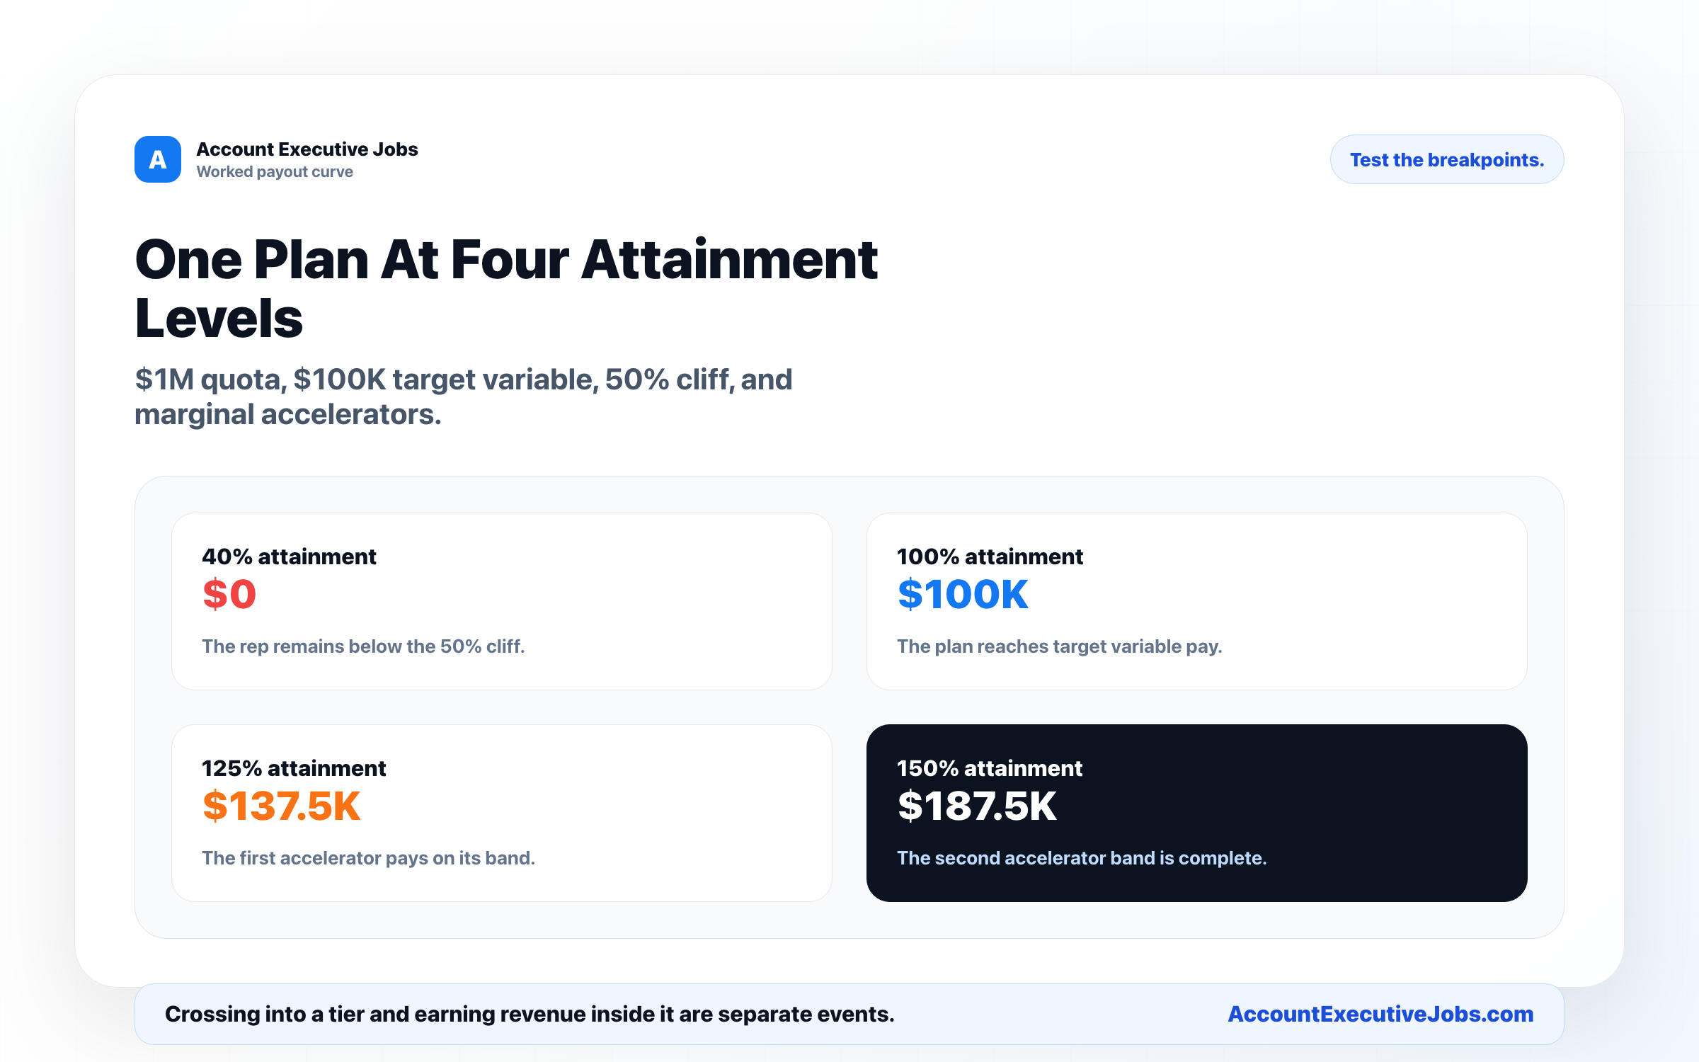

Use this reference
Read the full guide for the context behind this visual. The original illustration and its source belong together when you share it.

Notes

