

Commission Order Of Operations
  - Commission order of operations from quota credit through tiers, caps, bonuses, draws, and clawbacks.
https://accountexecutivejobs.com/blog/sales-compensation/sales-commission-tiers-cliffs-accelerators
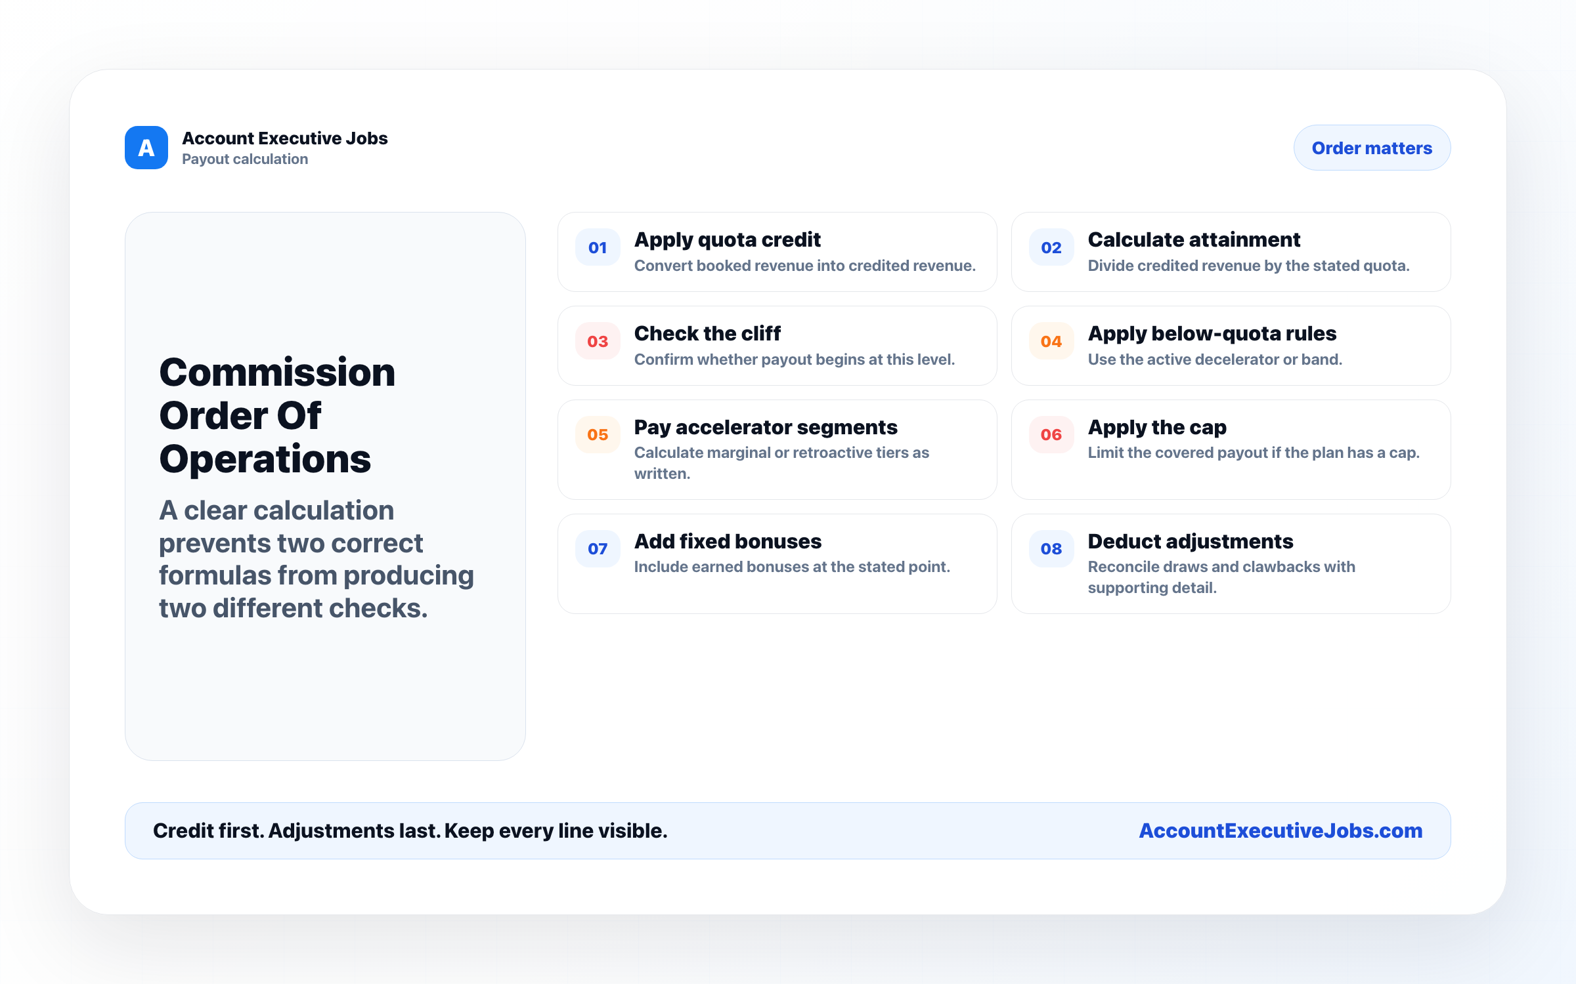

Use this reference
Read the full guide for the context behind this visual. The original illustration and its source belong together when you share it.

Notes

