

Marginal vs Retroactive Commission
  - Comparison of marginal and retroactive sales commission tiers.
https://accountexecutivejobs.com/blog/sales-compensation/sales-commission-tiers-cliffs-accelerators
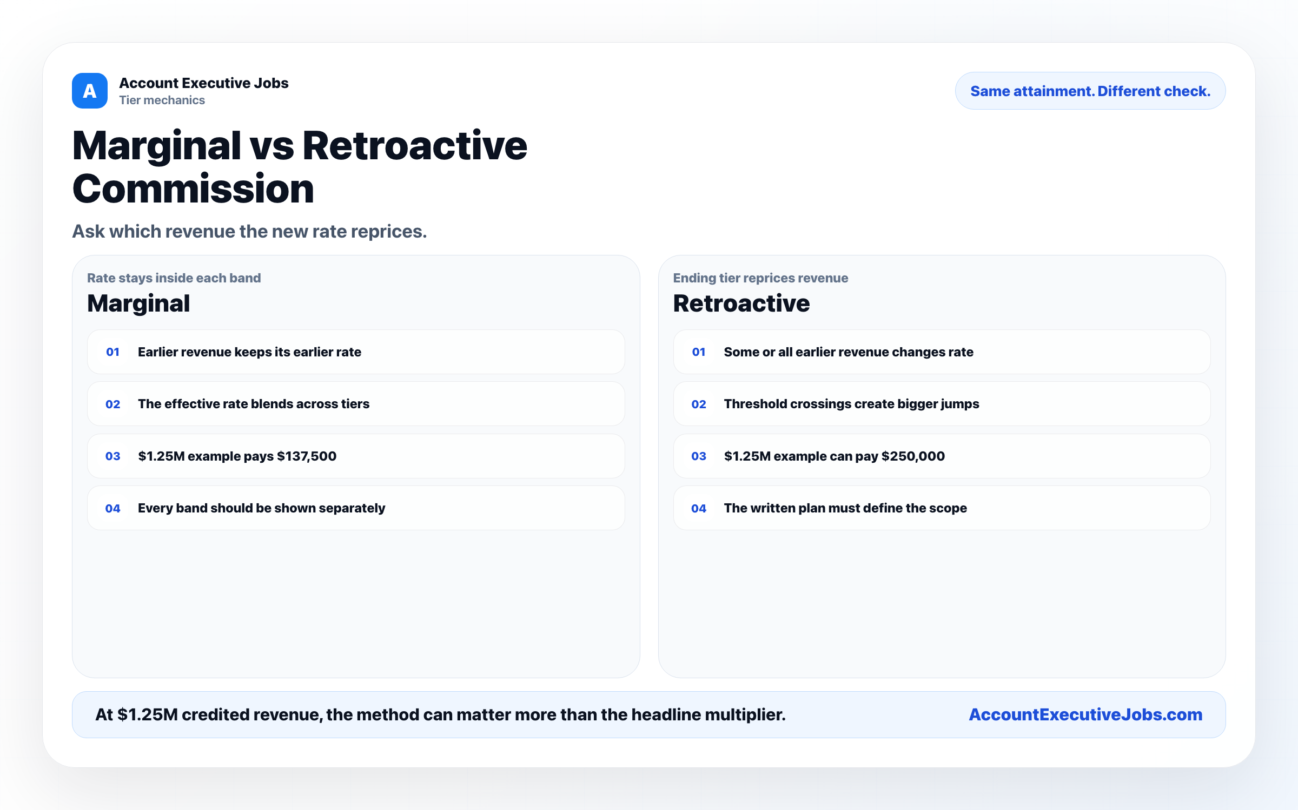

Use this reference
Read the full guide for the context behind this visual. The original illustration and its source belong together when you share it.

Notes

