

Required Opportunities vs Closeable Capacity
  - Example comparing 48 required qualified opportunities with capacity for 36 opportunities that can close inside the quota year.
https://accountexecutivejobs.com/blog/sales-management/how-to-set-a-realistic-sales-quota
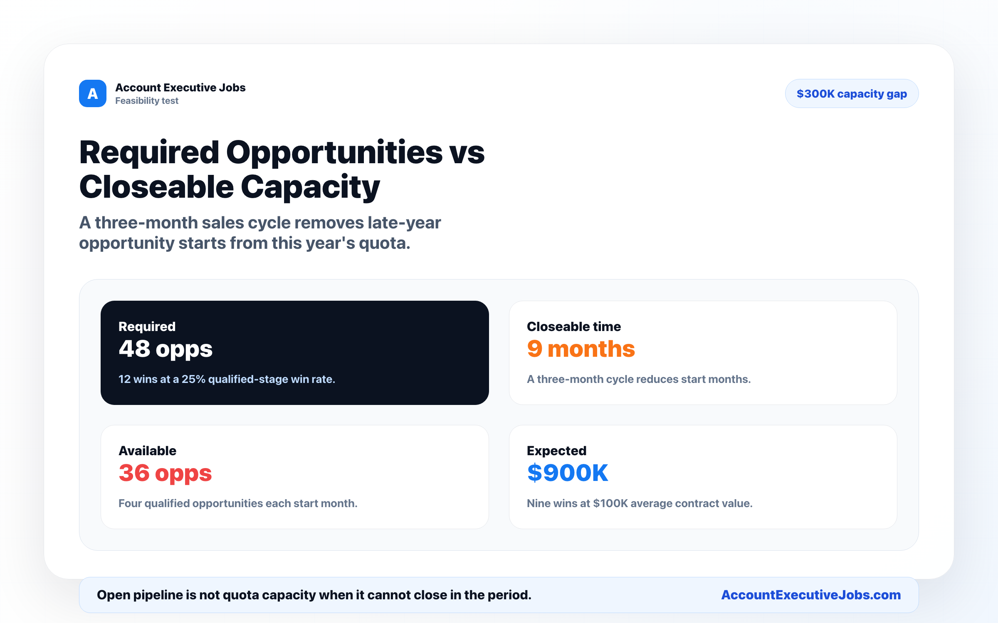

Use this reference
Read the full guide for the context behind this visual. The original illustration and its source belong together when you share it.

Notes

