

Clean Quota vs Fantasy Quota
  - Comparison between a realistic sales quota built from segmented evidence and a fantasy quota built from optimistic assumptions.
https://accountexecutivejobs.com/blog/sales-management/how-to-set-a-realistic-sales-quota
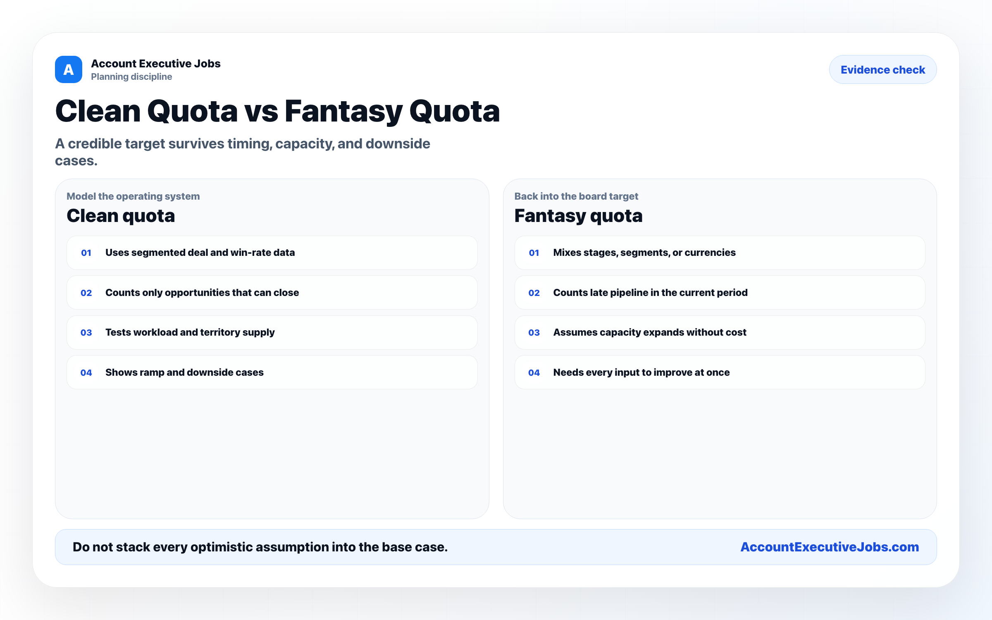

Use this reference
Read the full guide for the context behind this visual. The original illustration and its source belong together when you share it.

Notes

