

Best Sales Path By Strength
  - Best sales path by strength showing technical communicator, field operator, complex-deal seller, relationship builder, and sales manager fit.
https://accountexecutivejobs.com/blog/account-executive-jobs/highest-paying-sales-jobs
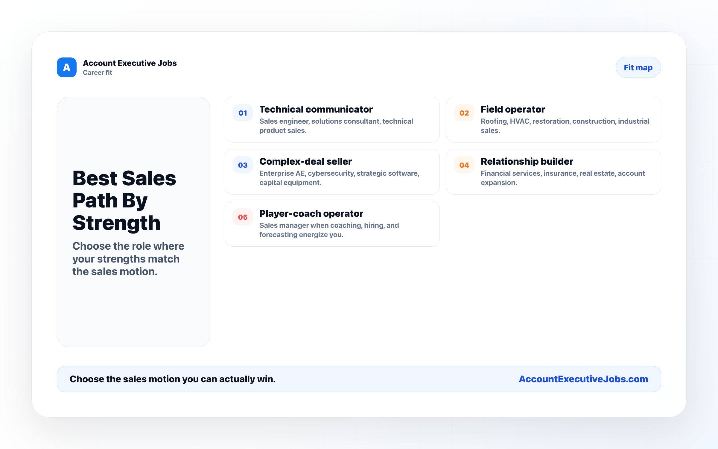

Use this reference
Read the full guide for the context behind this visual. The original illustration and its source belong together when you share it.

Notes

