

Pay Ceiling vs Pay Reliability
  - Pay ceiling versus pay reliability matrix for high-paying sales jobs including sales manager, sales engineer, enterprise AE, field sales, medical device, and real estate.
https://accountexecutivejobs.com/blog/account-executive-jobs/highest-paying-sales-jobs
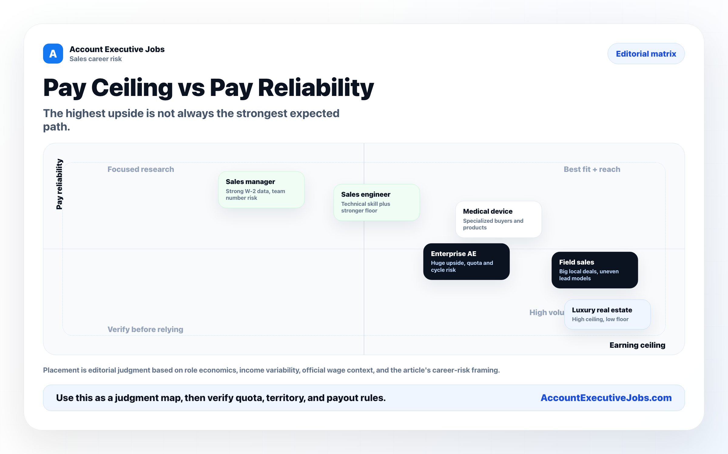

Use this reference
Read the full guide for the context behind this visual. The original illustration and its source belong together when you share it.

Notes

