

High Pay Comes From The Setup
  - Animated infographic showing the five-part money path behind high-paying sales jobs: big deal size, demand, margin, territory access, and a written commission plan.
https://accountexecutivejobs.com/blog/account-executive-jobs/highest-paying-sales-jobs
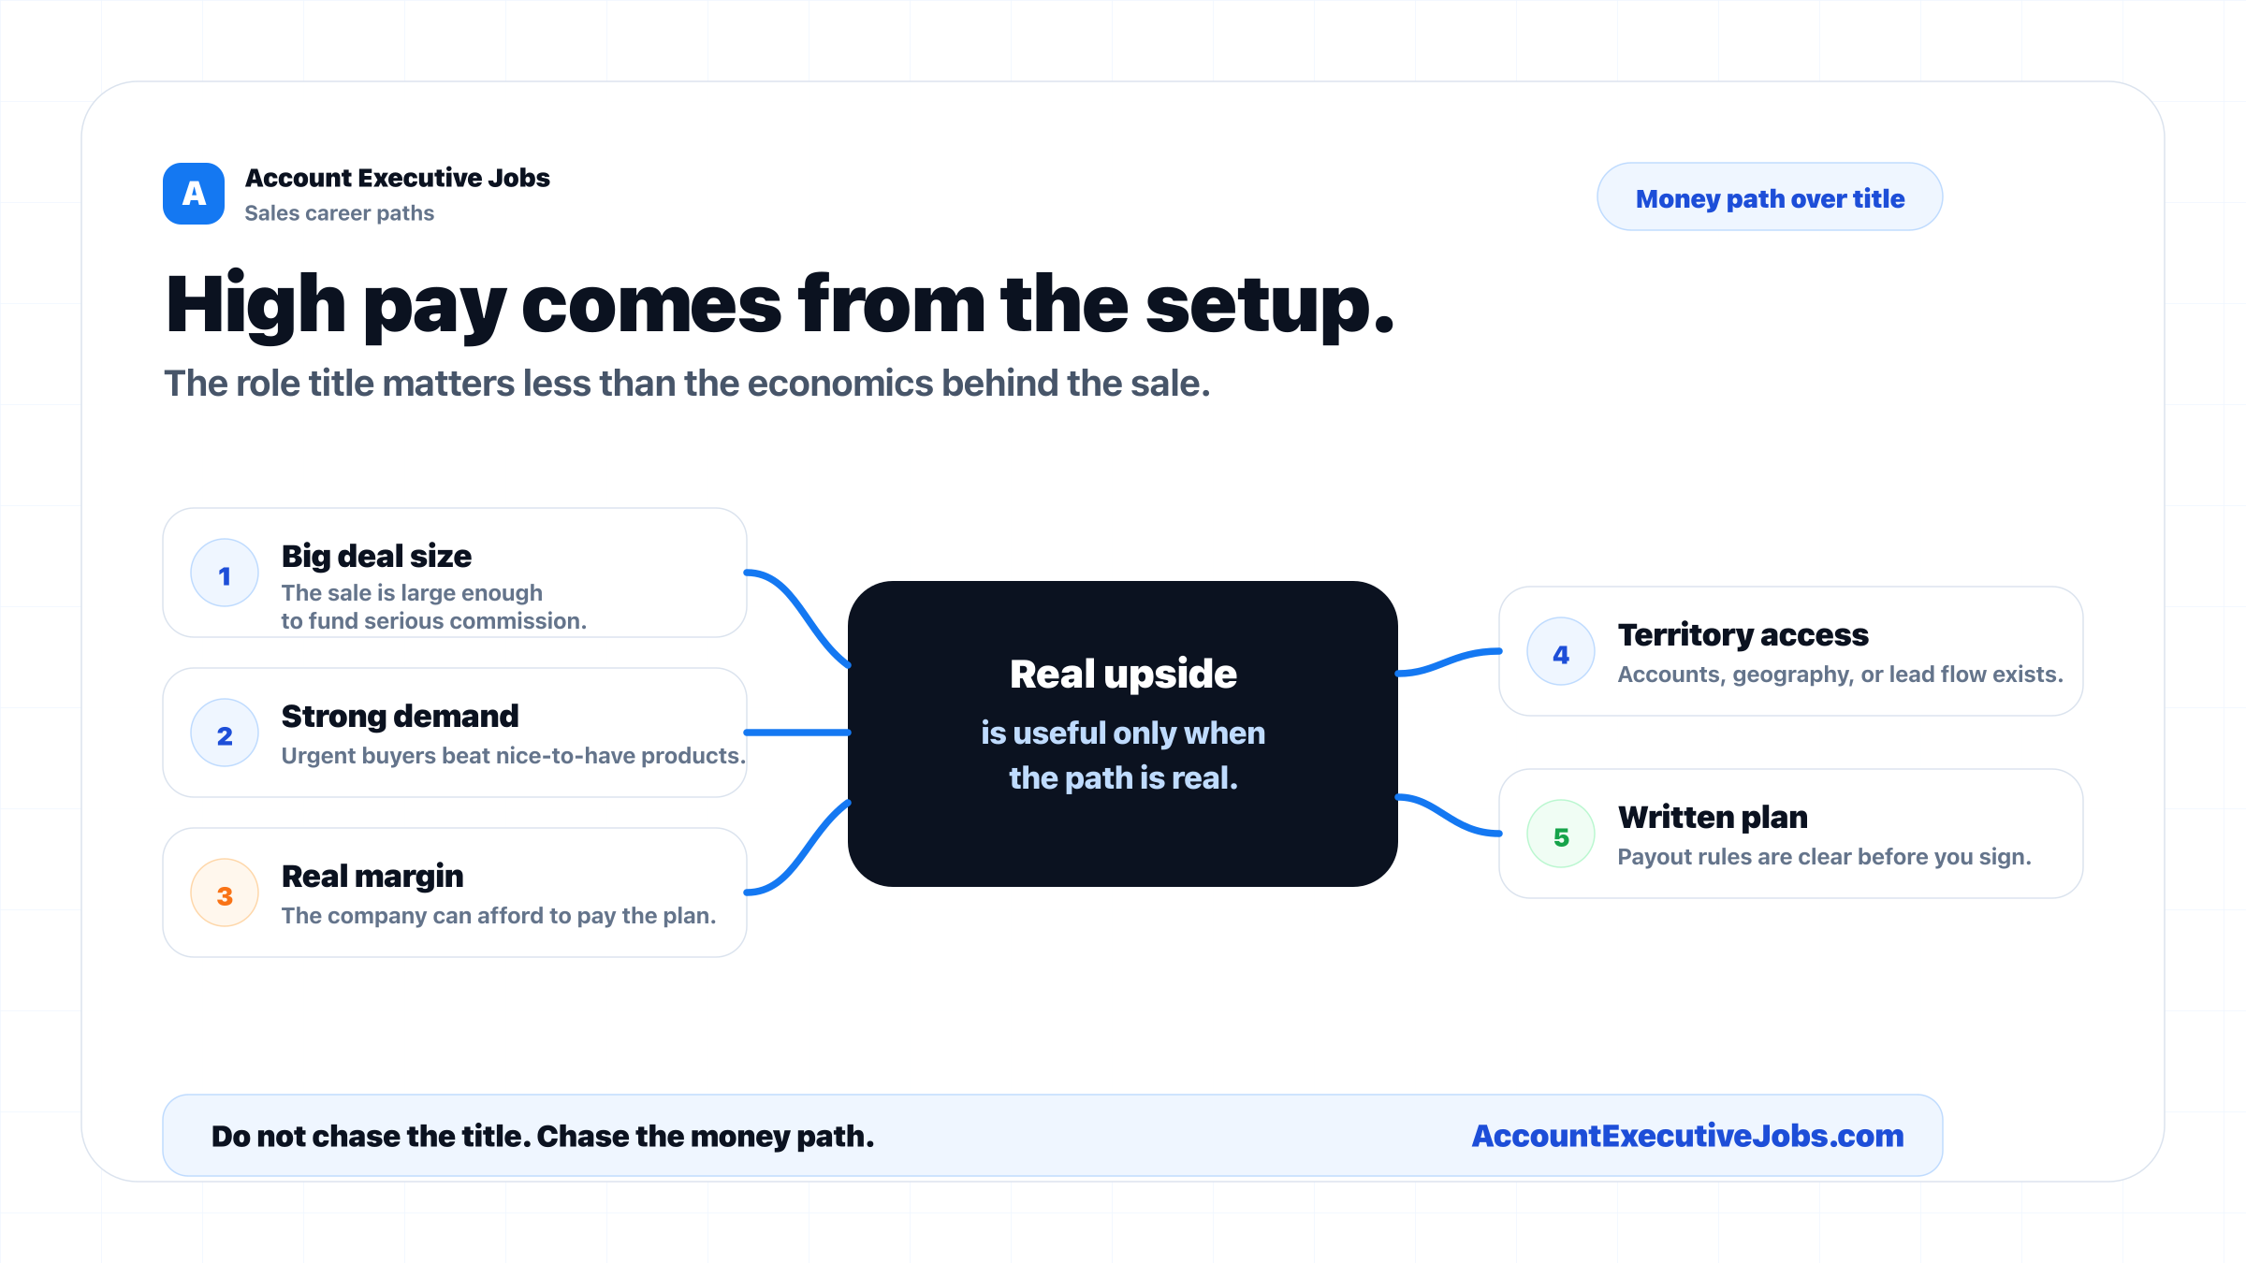

Use this reference
Read the full guide for the context behind this visual. The original illustration and its source belong together when you share it.

Notes

