

Questions Before You Chase The Upside
  - Questions before chasing a high-paying sales job covering average deal size, median ramped earnings, quota attainment, lead source, sales cycle, payout timing, and recent rep outcomes.
https://accountexecutivejobs.com/blog/account-executive-jobs/highest-paying-sales-jobs
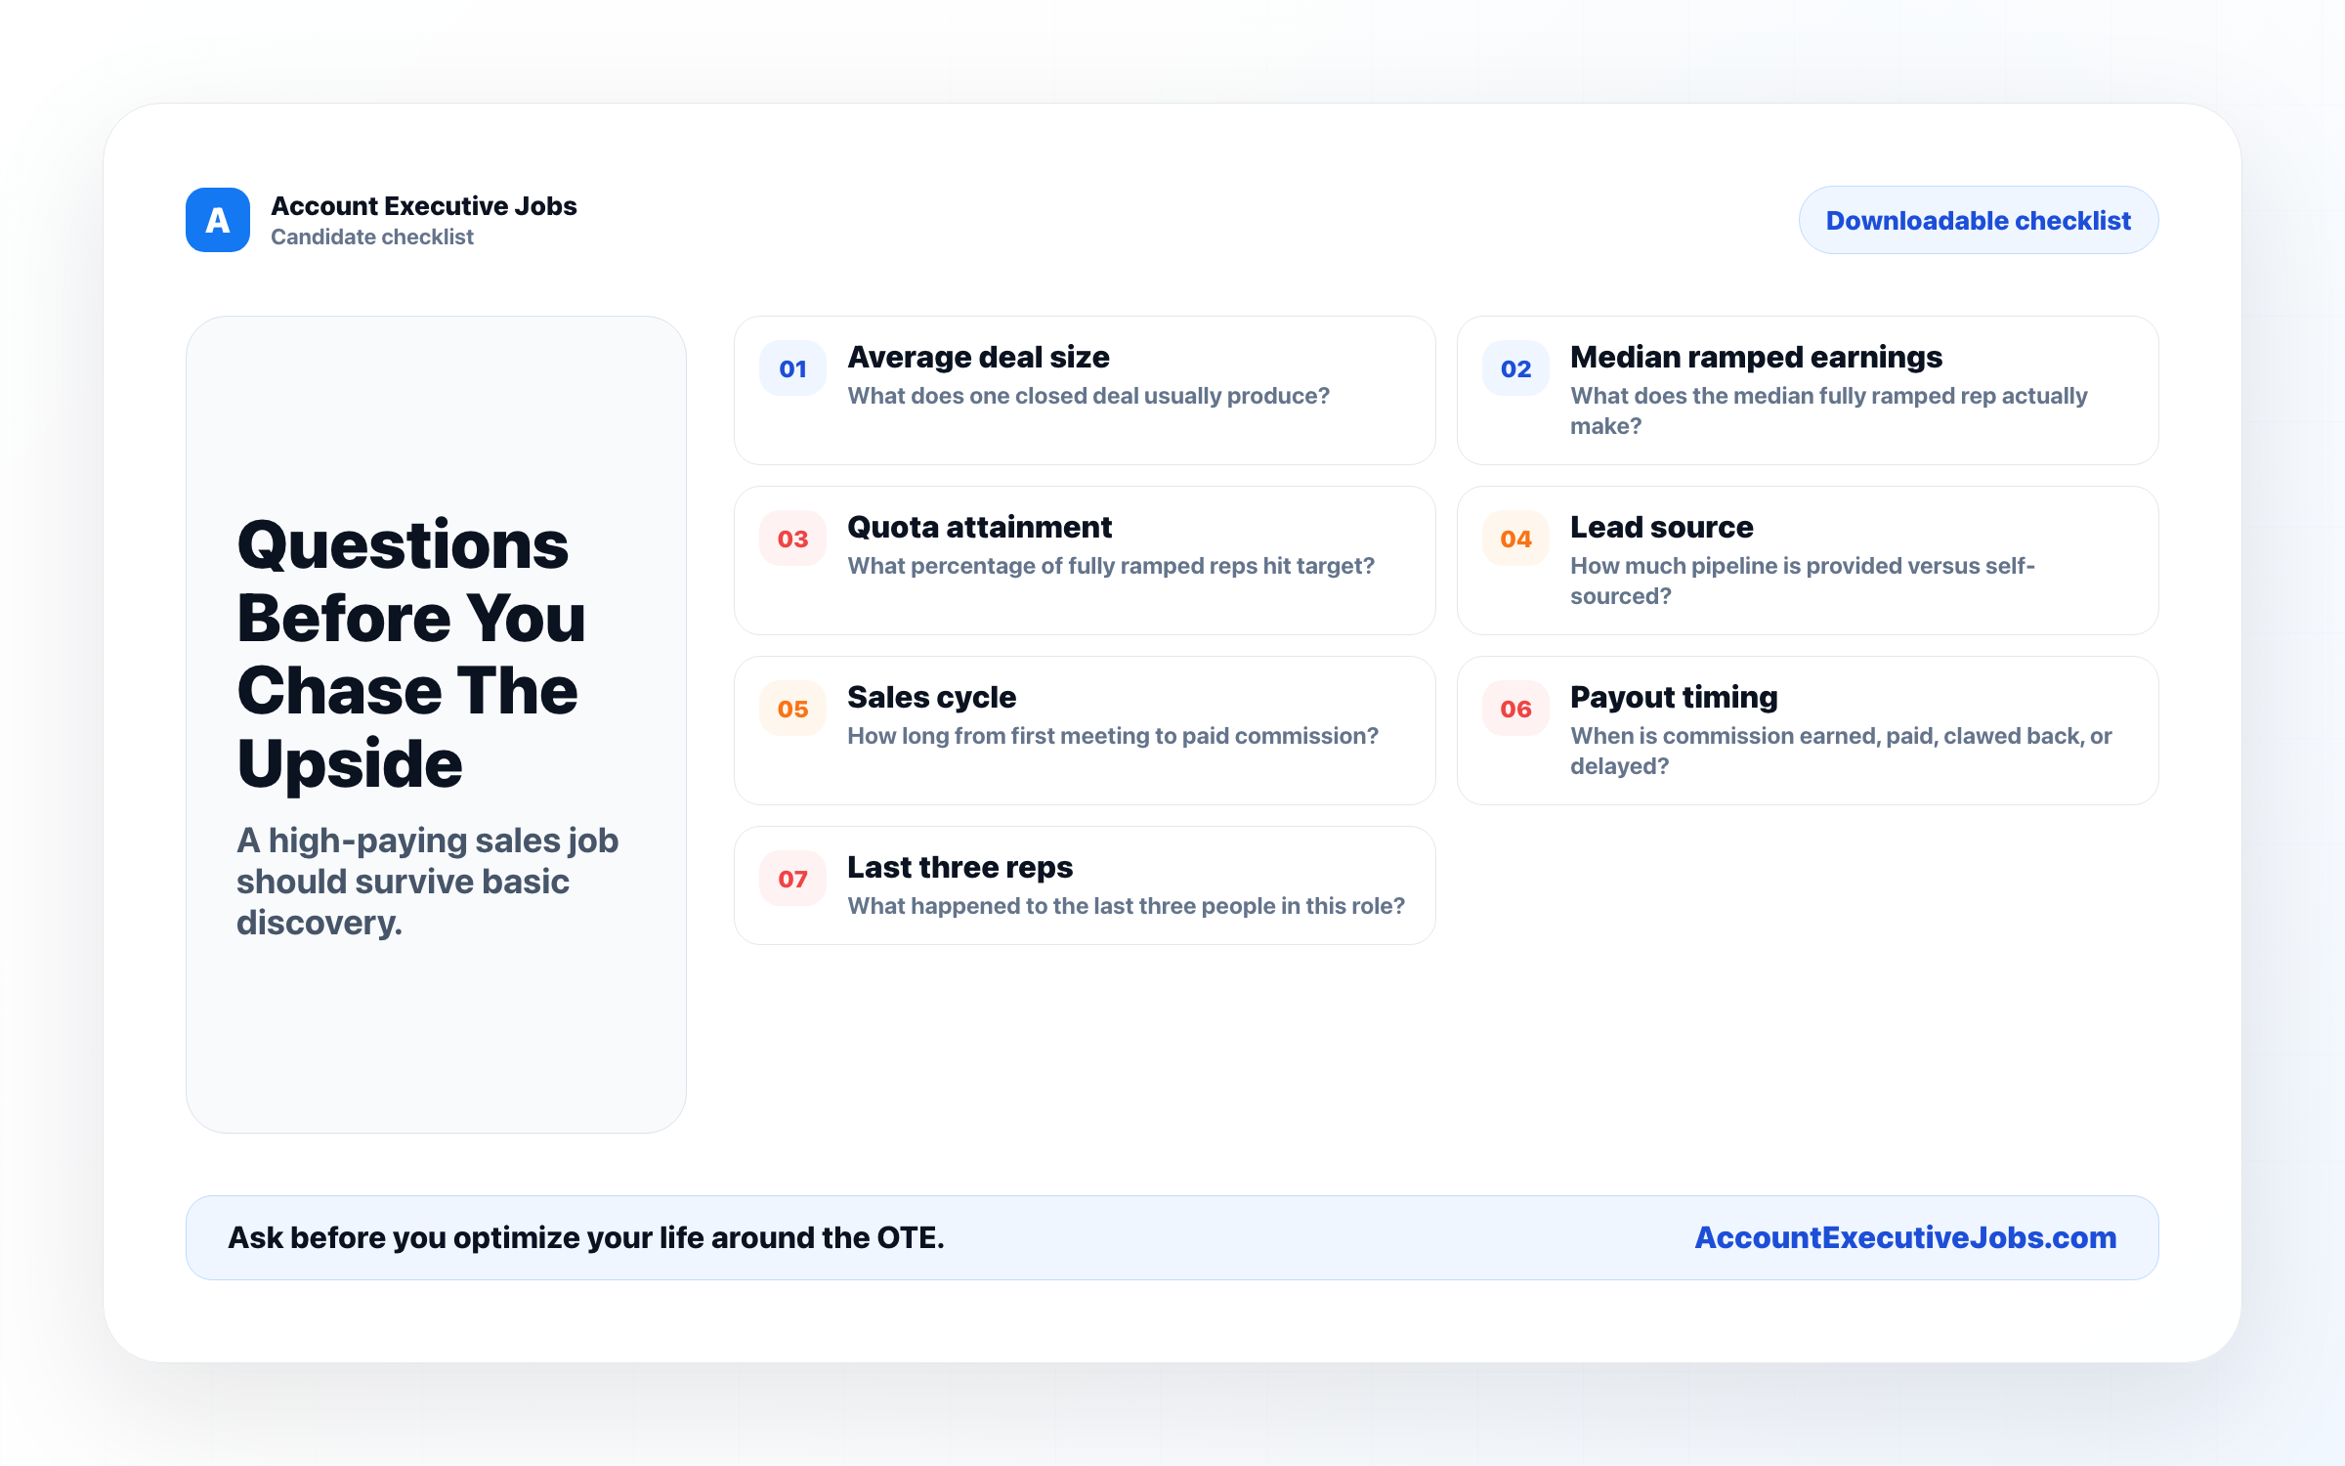

Use this reference
Read the full guide for the context behind this visual. The original illustration and its source belong together when you share it.

Notes

