

Sales Rep Turnover Cost Example
  - Worked sales rep turnover cost example showing vacancy loss, ramp loss, direct cost, savings, and net turnover cost.
https://accountexecutivejobs.com/blog/hiring-salespeople/cost-of-hiring-and-replacing-an-account-executive
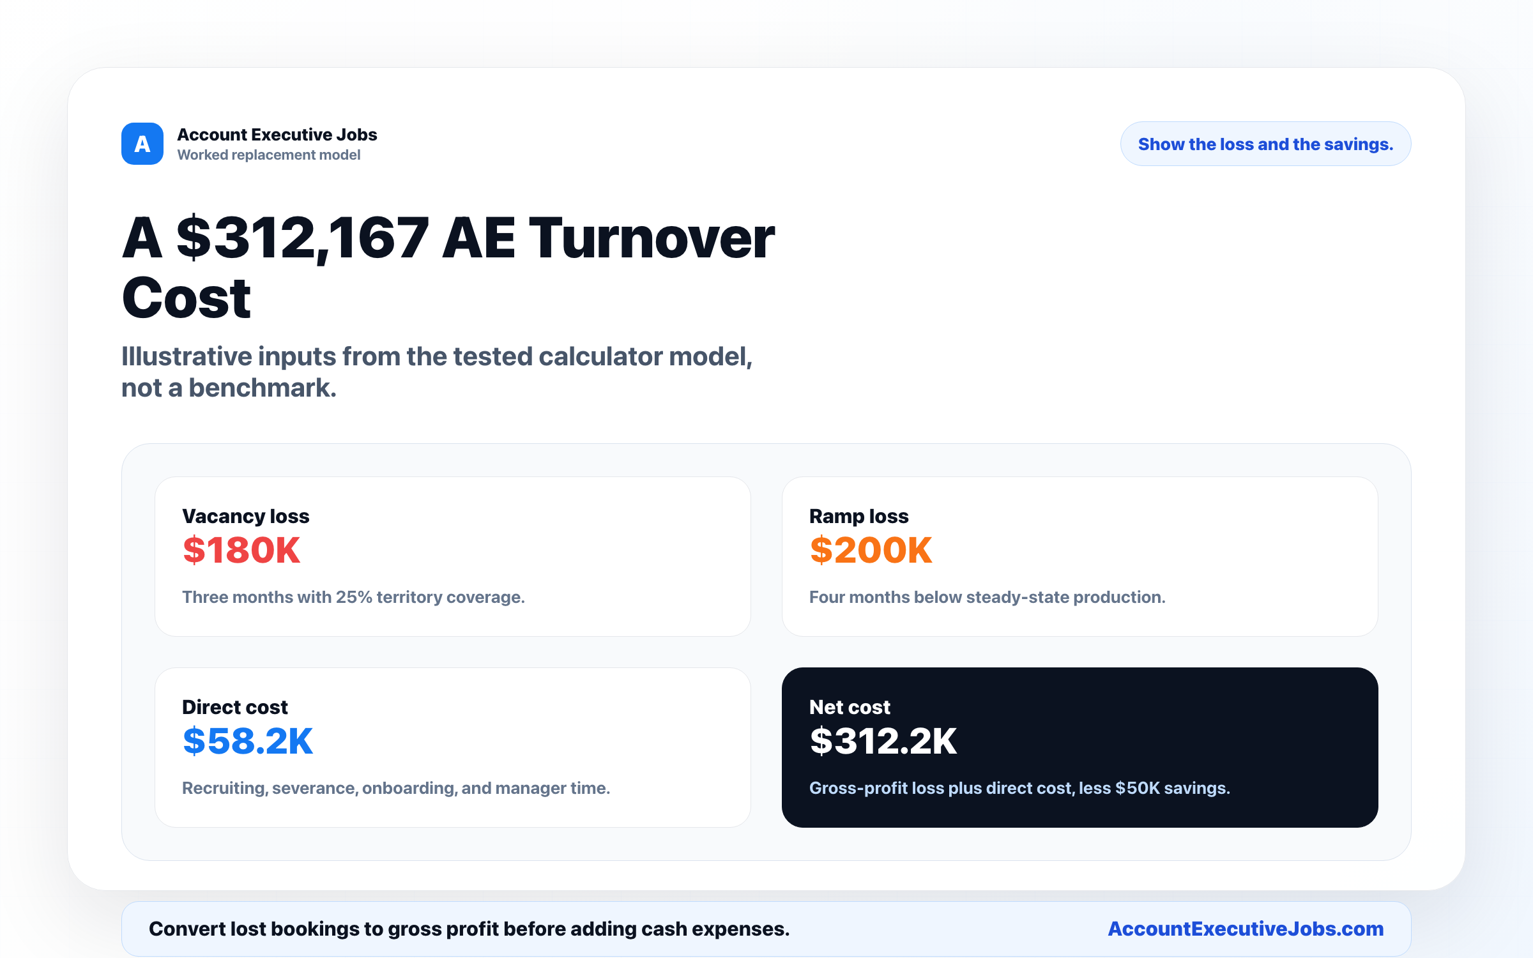

Use this reference
Read the full guide for the context behind this visual. The original illustration and its source belong together when you share it.

Notes

