

First-Year Hire Cost vs Replacement Cost
  - Comparison of first-year account executive hiring cost and incremental sales rep replacement cost.
https://accountexecutivejobs.com/blog/hiring-salespeople/cost-of-hiring-and-replacing-an-account-executive
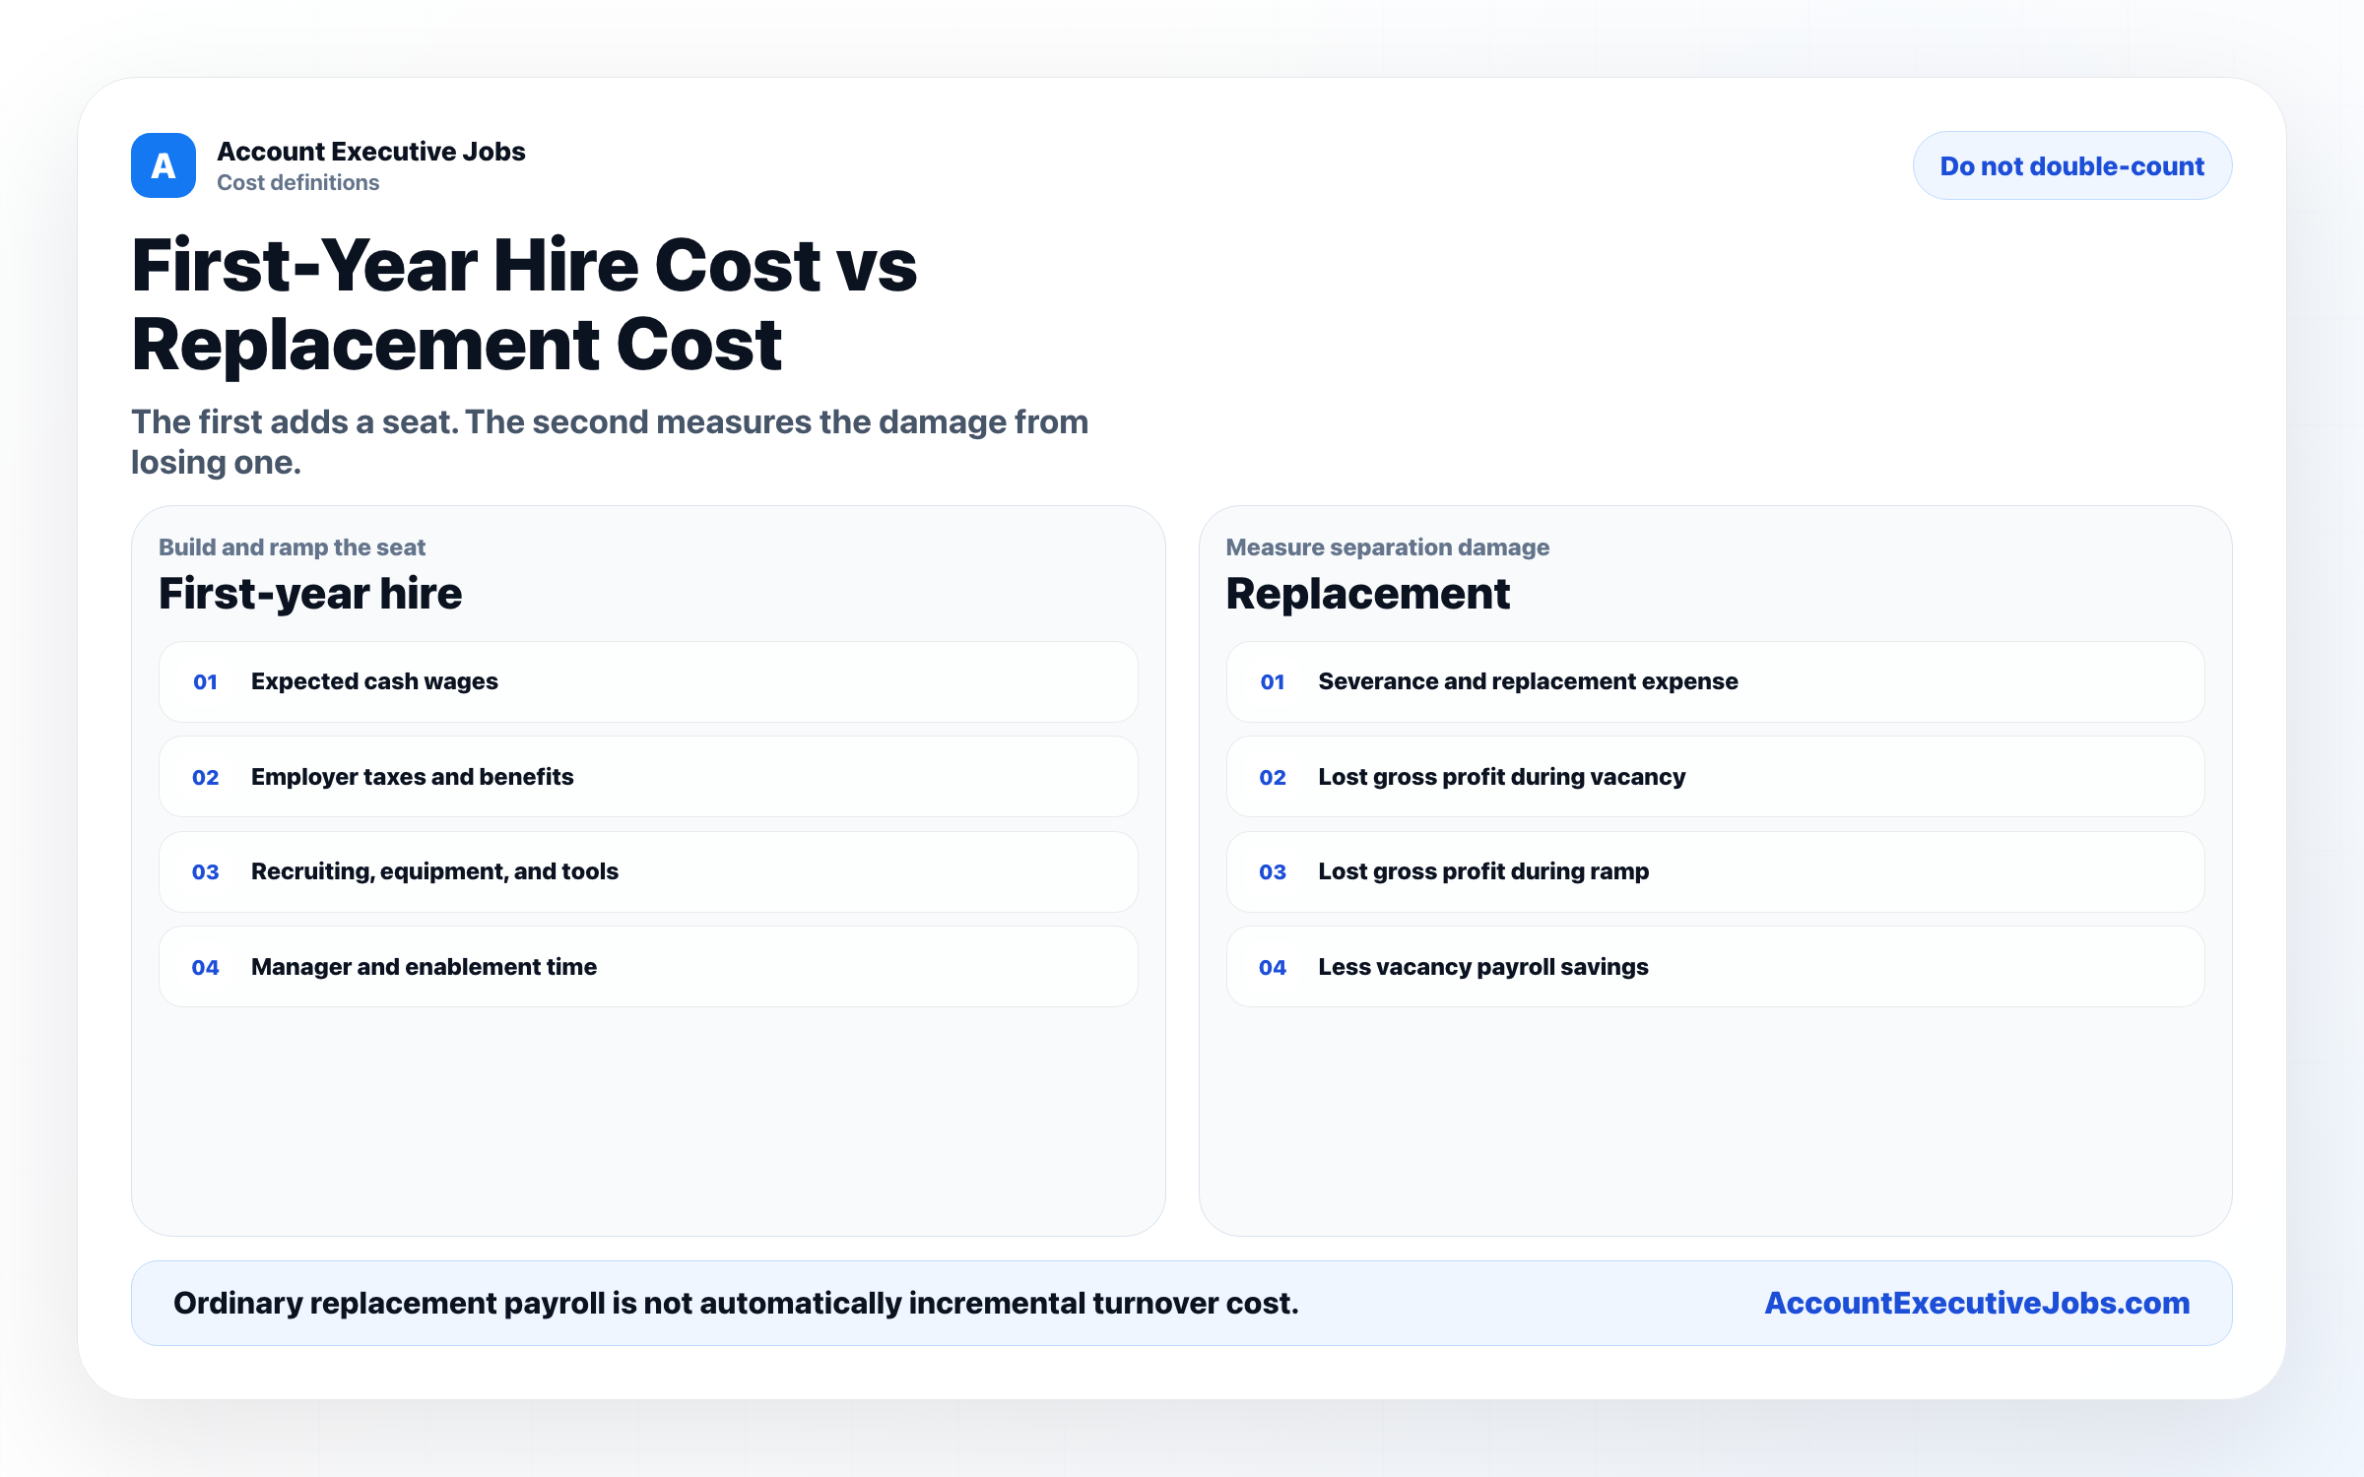

Use this reference
Read the full guide for the context behind this visual. The original illustration and its source belong together when you share it.

Notes

