

Fully Loaded AE Cost Stack
  - Fully loaded account executive cost stack covering wages, payroll taxes, benefits, recruiting, tools, and manager ramp time.
https://accountexecutivejobs.com/blog/hiring-salespeople/cost-of-hiring-and-replacing-an-account-executive
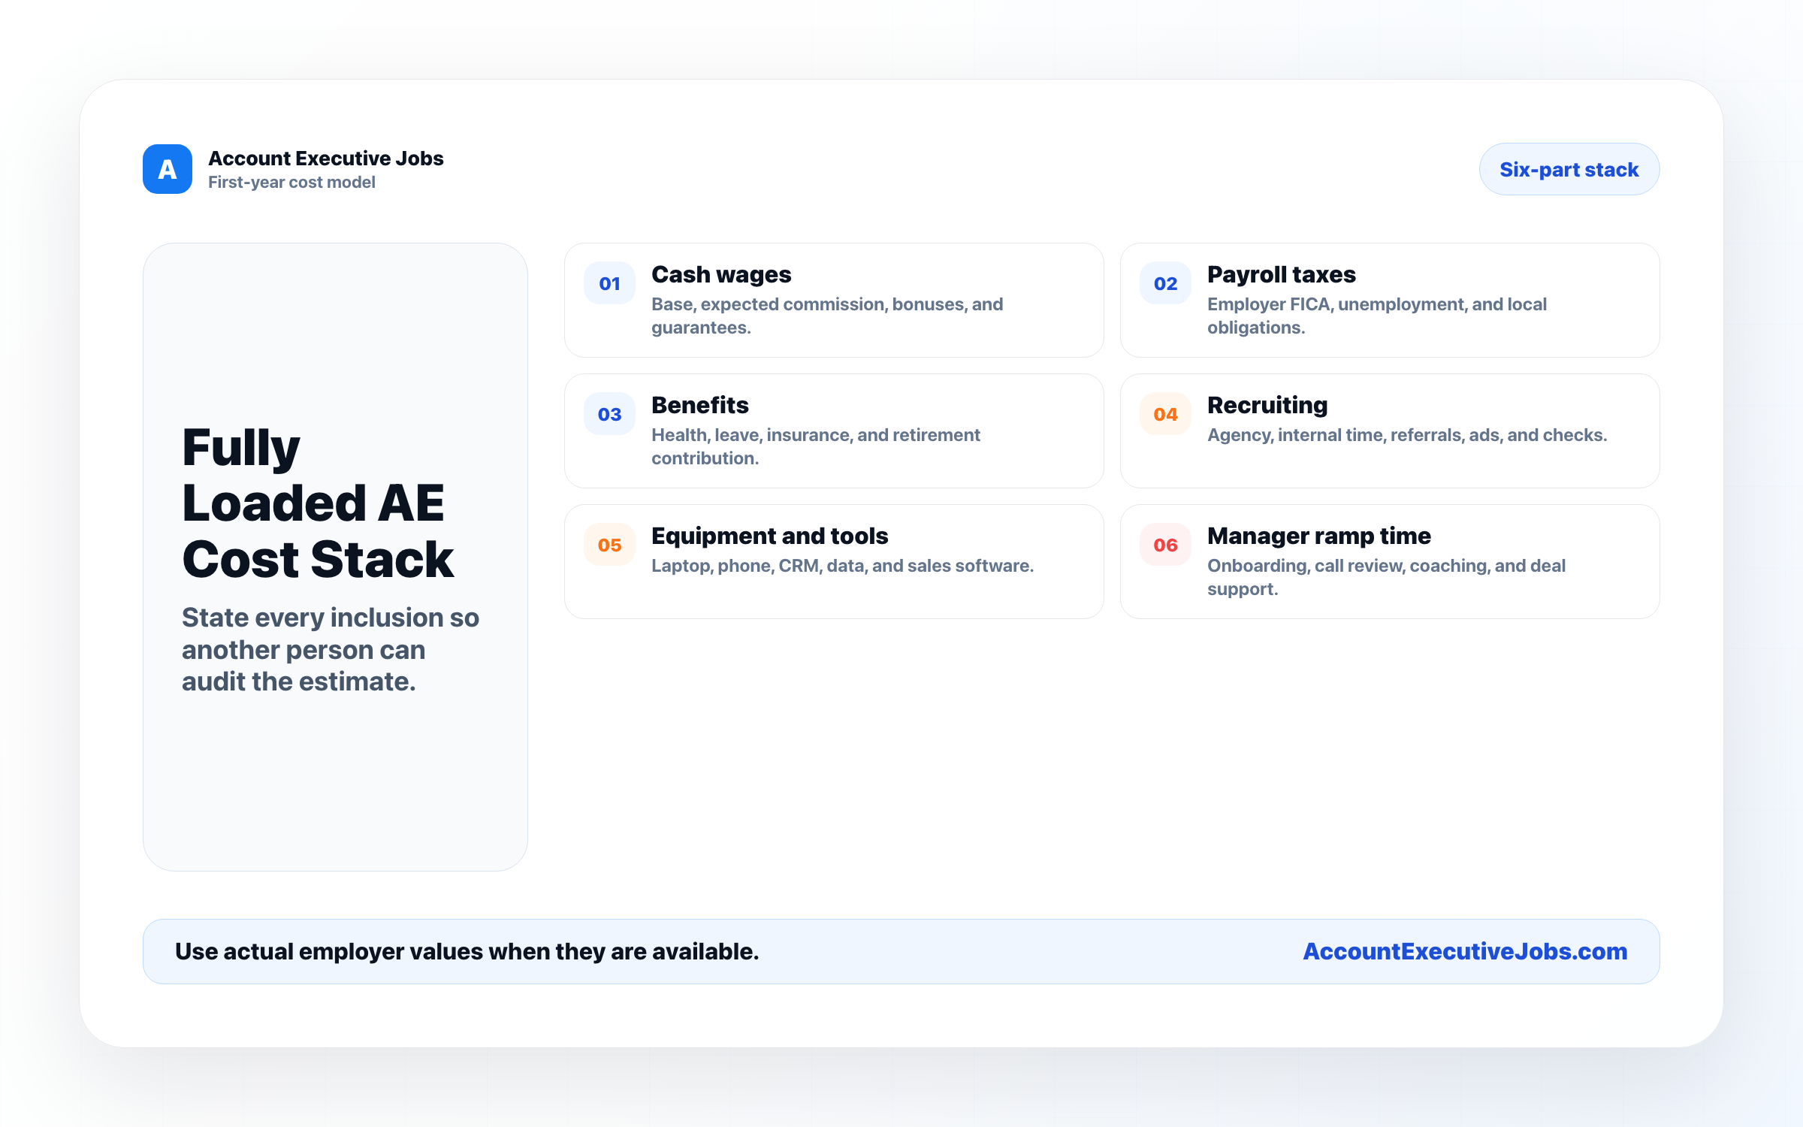

Use this reference
Read the full guide for the context behind this visual. The original illustration and its source belong together when you share it.

Notes

