

From Salary To Fully Loaded AE Cost
  - Animated cost model adding cash wages, employer costs, ramp costs, and turnover disruption.
https://accountexecutivejobs.com/blog/hiring-salespeople/cost-of-hiring-and-replacing-an-account-executive
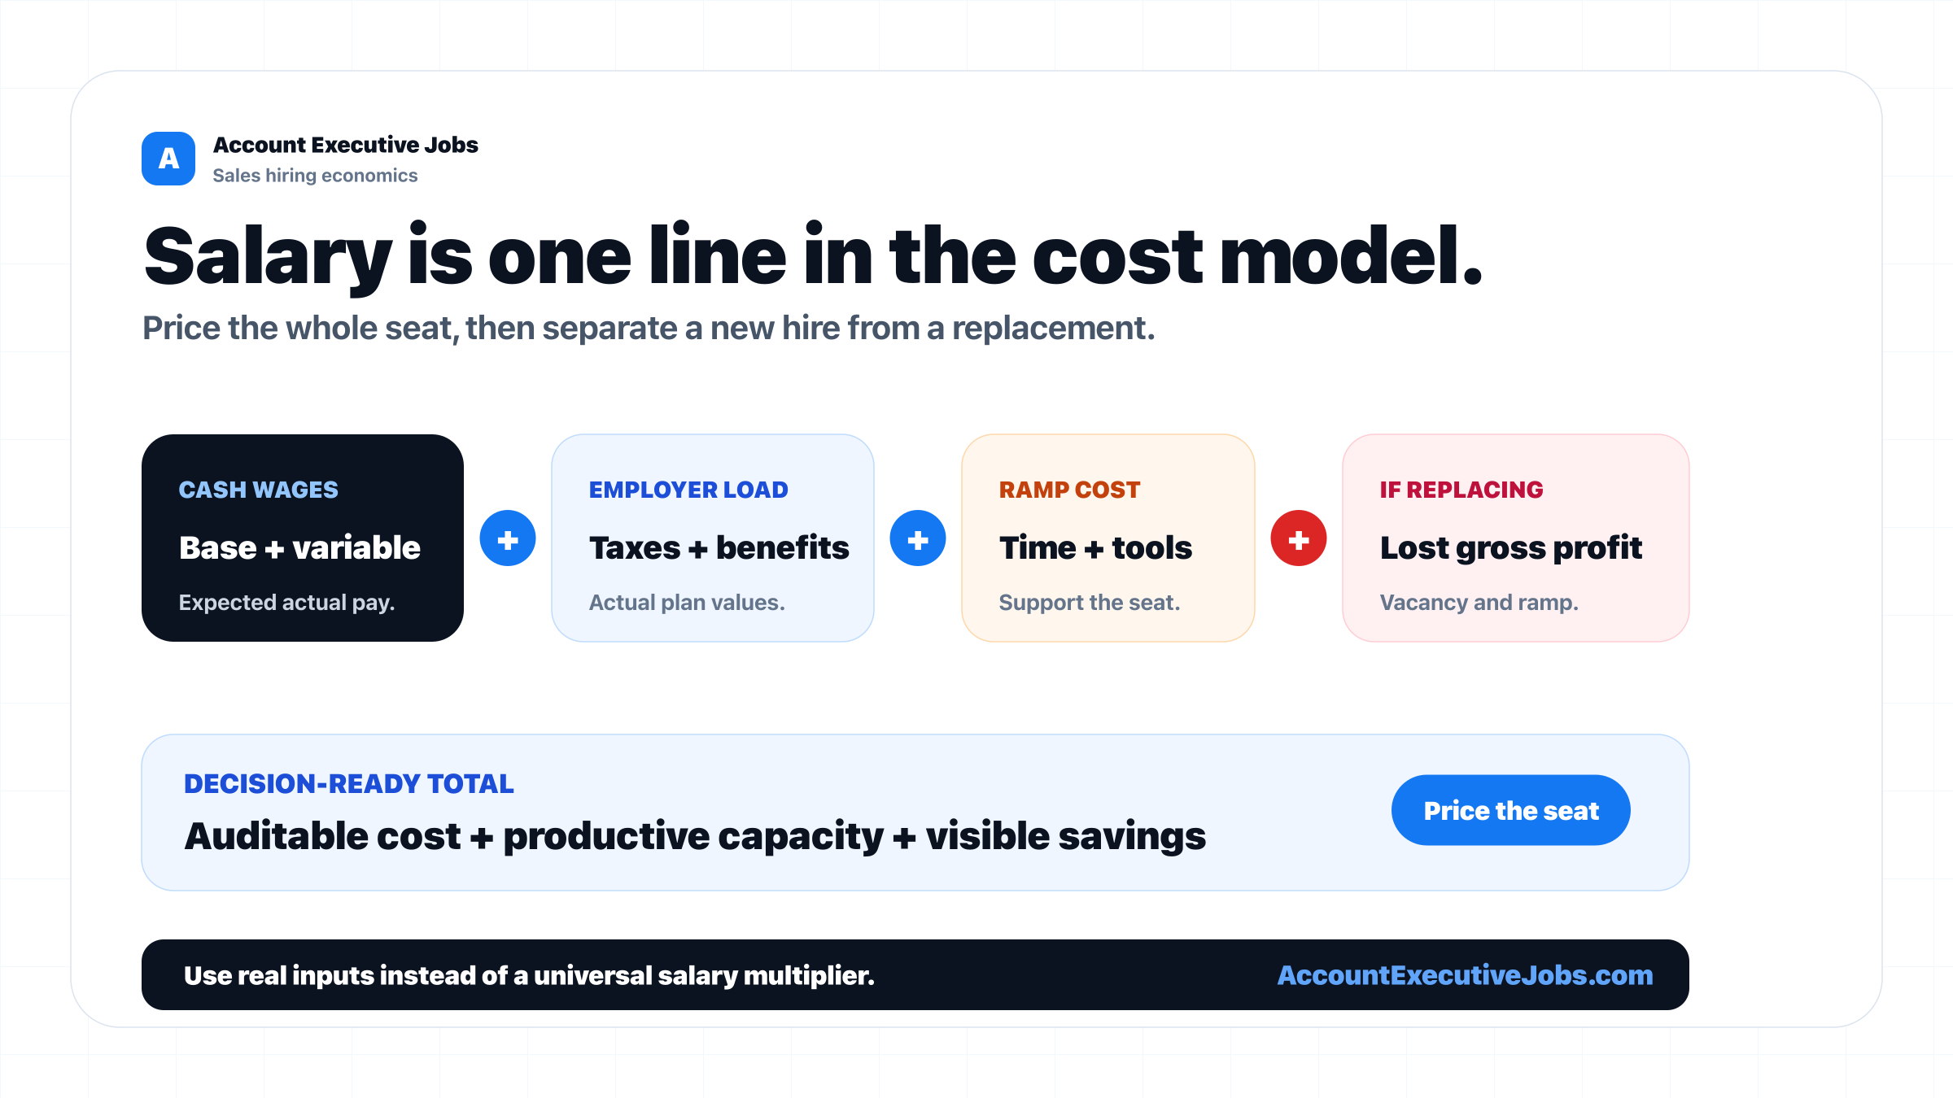

Use this reference
Read the full guide for the context behind this visual. The original illustration and its source belong together when you share it.

Notes

