

AE Cost Input Checklist
  - Account executive cost checklist covering compensation, employer taxes, benefits, recruiting, equipment, manager time, vacancy, and ramp.
https://accountexecutivejobs.com/blog/hiring-salespeople/cost-of-hiring-and-replacing-an-account-executive
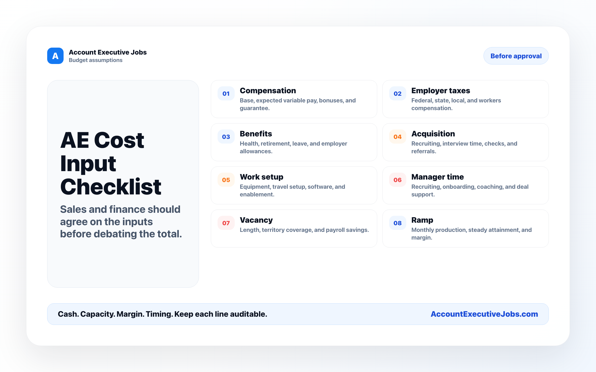

Use this reference
Read the full guide for the context behind this visual. The original illustration and its source belong together when you share it.

Notes

