

Volume vs Sales-Role Fit
  - Sales job board matrix comparing applicant volume with sales-role fit.
https://accountexecutivejobs.com/blog/sales-recruiting/best-sales-job-boards
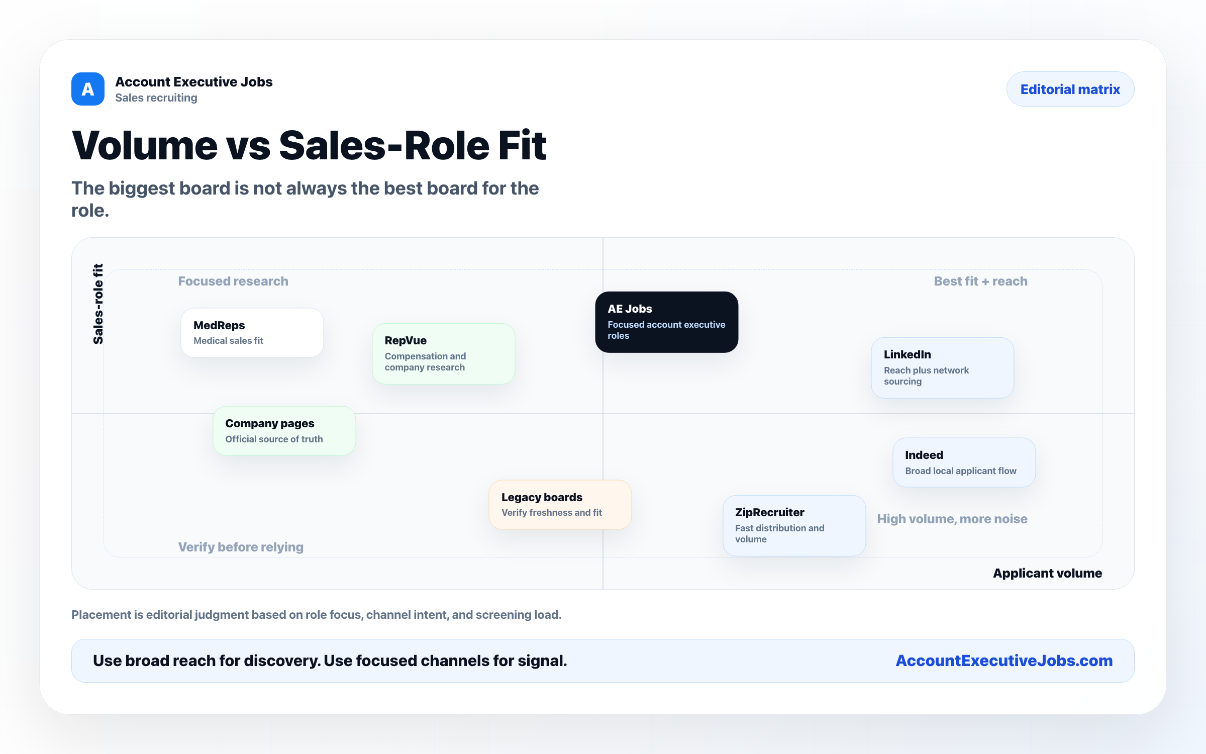

Use this reference
Read the full guide for the context behind this visual. The original illustration and its source belong together when you share it.

Notes

