

Choose The Board From The Role
  - Animated infographic showing how different sales hiring goals route to different job board choices: Account Executive Jobs, broad boards, RepVue, and niche boards.
https://accountexecutivejobs.com/blog/sales-recruiting/best-sales-job-boards
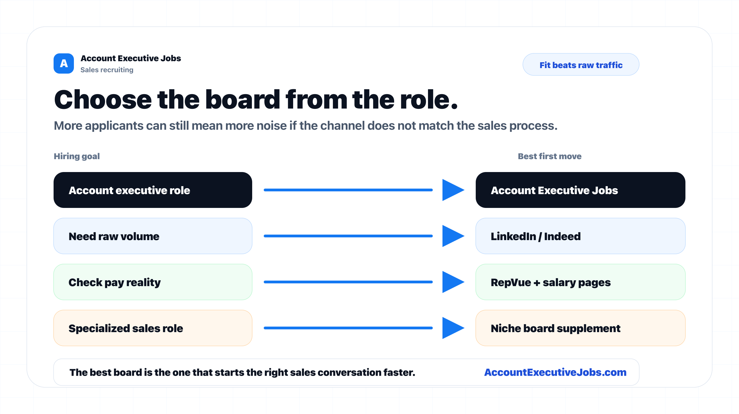

Use this reference
Read the full guide for the context behind this visual. The original illustration and its source belong together when you share it.

Notes

