

Where To Post Sales Jobs
  - Where to post sales jobs by role type including account executive, enterprise AE, SDR, field sales, medical sales, remote sales, and tech sales.
https://accountexecutivejobs.com/blog/sales-recruiting/best-sales-job-boards
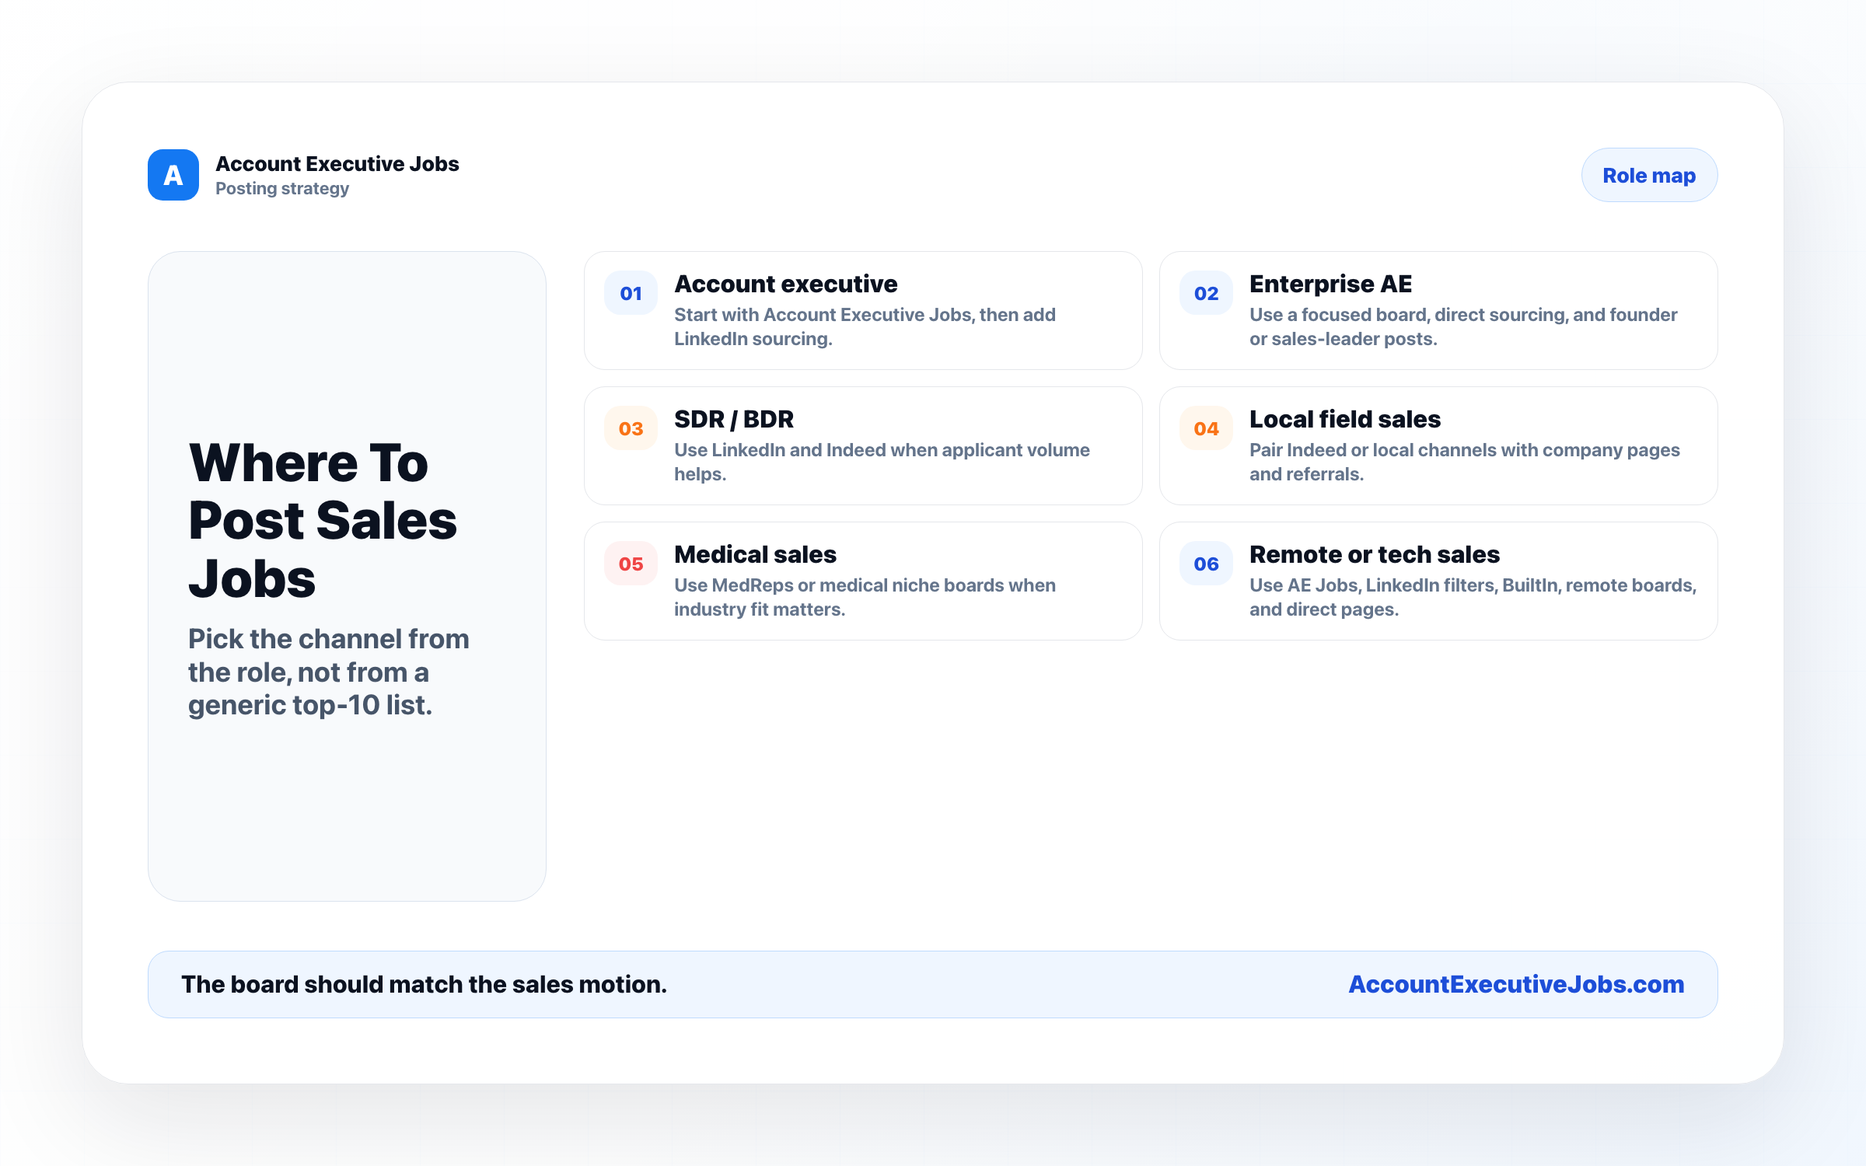

Use this reference
Read the full guide for the context behind this visual. The original illustration and its source belong together when you share it.

Notes

