

A Better Sales Hiring Stack
  - Employer sales hiring board stack showing focused board, network sourcing, compensation benchmark, niche supplement, and screening process.
https://accountexecutivejobs.com/blog/sales-recruiting/best-sales-job-boards
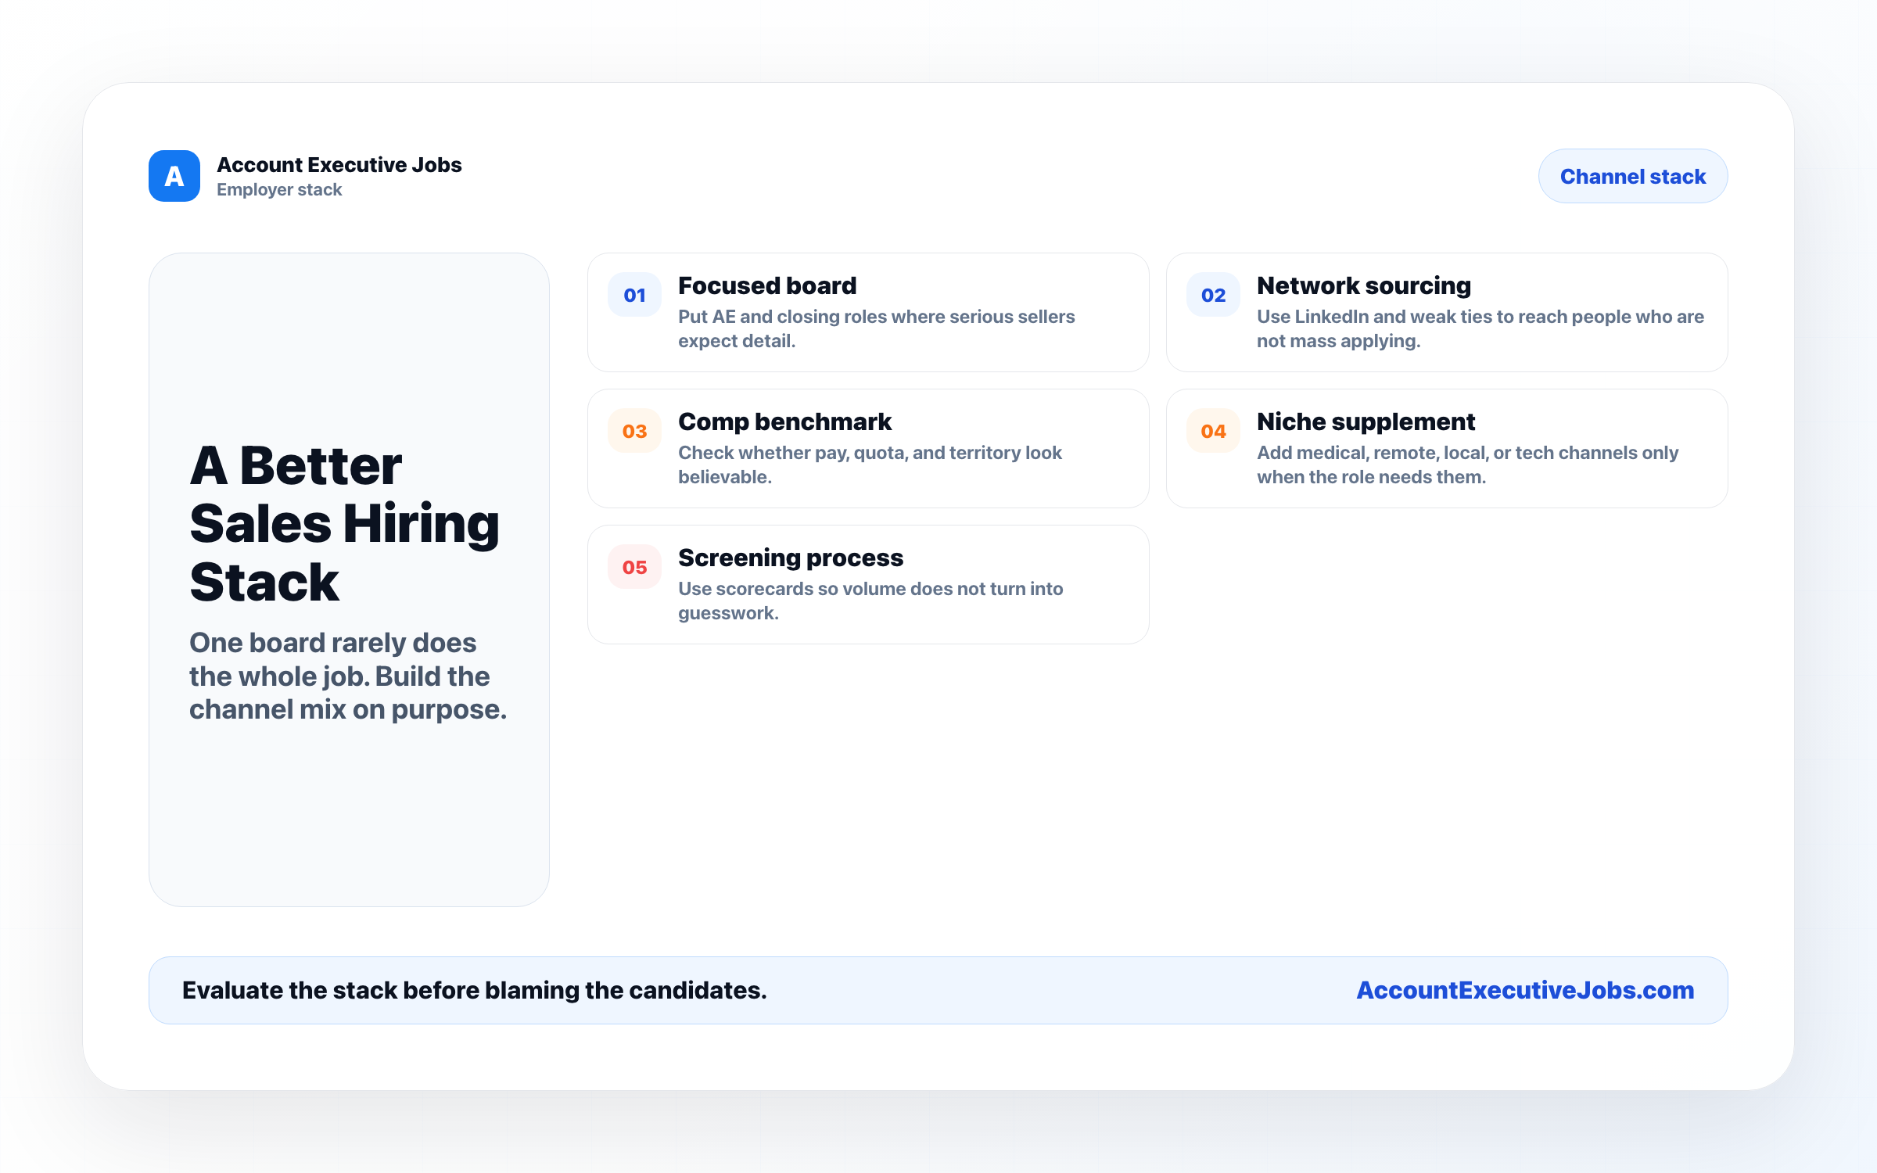

Use this reference
Read the full guide for the context behind this visual. The original illustration and its source belong together when you share it.

Notes

