

Sales Job Search Stack
  - Sales job search stack for candidates showing focused AE roles, broader boards, company career pages, pay research, outreach, and red-flag checks.
https://accountexecutivejobs.com/blog/sales-recruiting/best-sales-job-boards
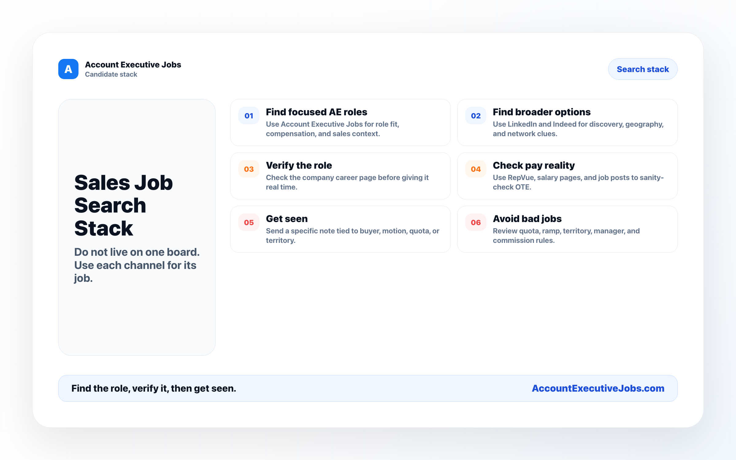

Use this reference
Read the full guide for the context behind this visual. The original illustration and its source belong together when you share it.

Notes

