

AE Pay Questions To Ask
  - Account executive pay questions checklist covering base, variable pay, quota, attainment, ramp, territory, payout timing, and plan rules.
https://accountexecutivejobs.com/blog/sales-compensation/account-executive-salary
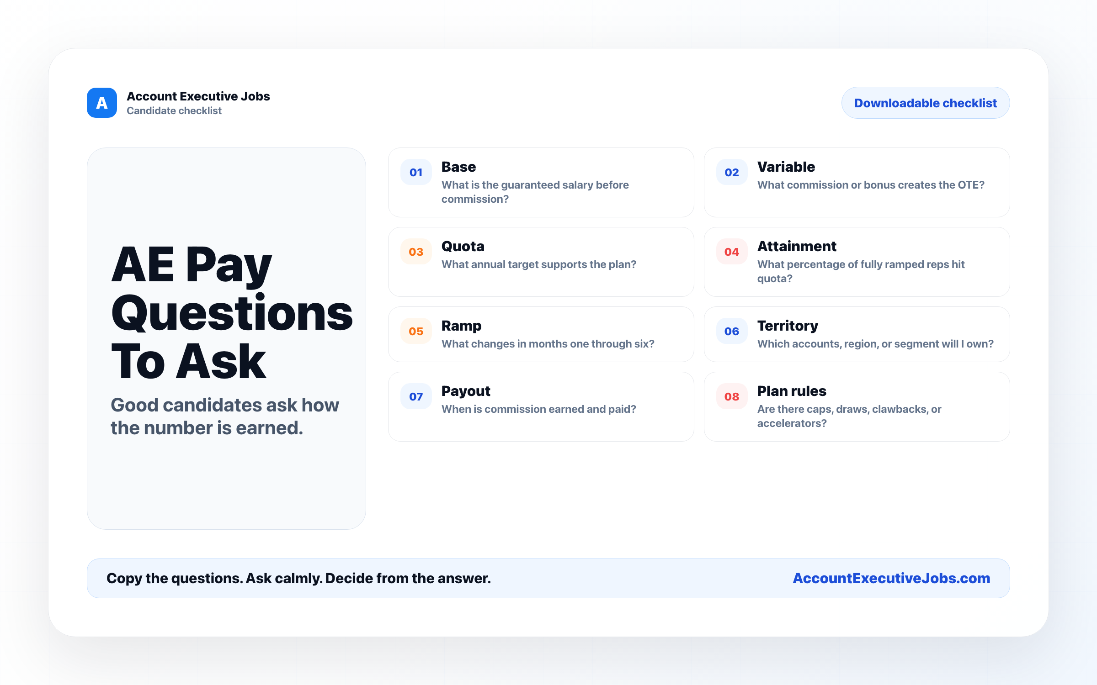

Use this reference
Read the full guide for the context behind this visual. The original illustration and its source belong together when you share it.

Notes

