

OTE Reality Check
  - OTE reality check for account executive salary covering base pay, quota, attainment, ramp, territory, payout timing, clawbacks, and the written plan.
https://accountexecutivejobs.com/blog/sales-compensation/account-executive-salary
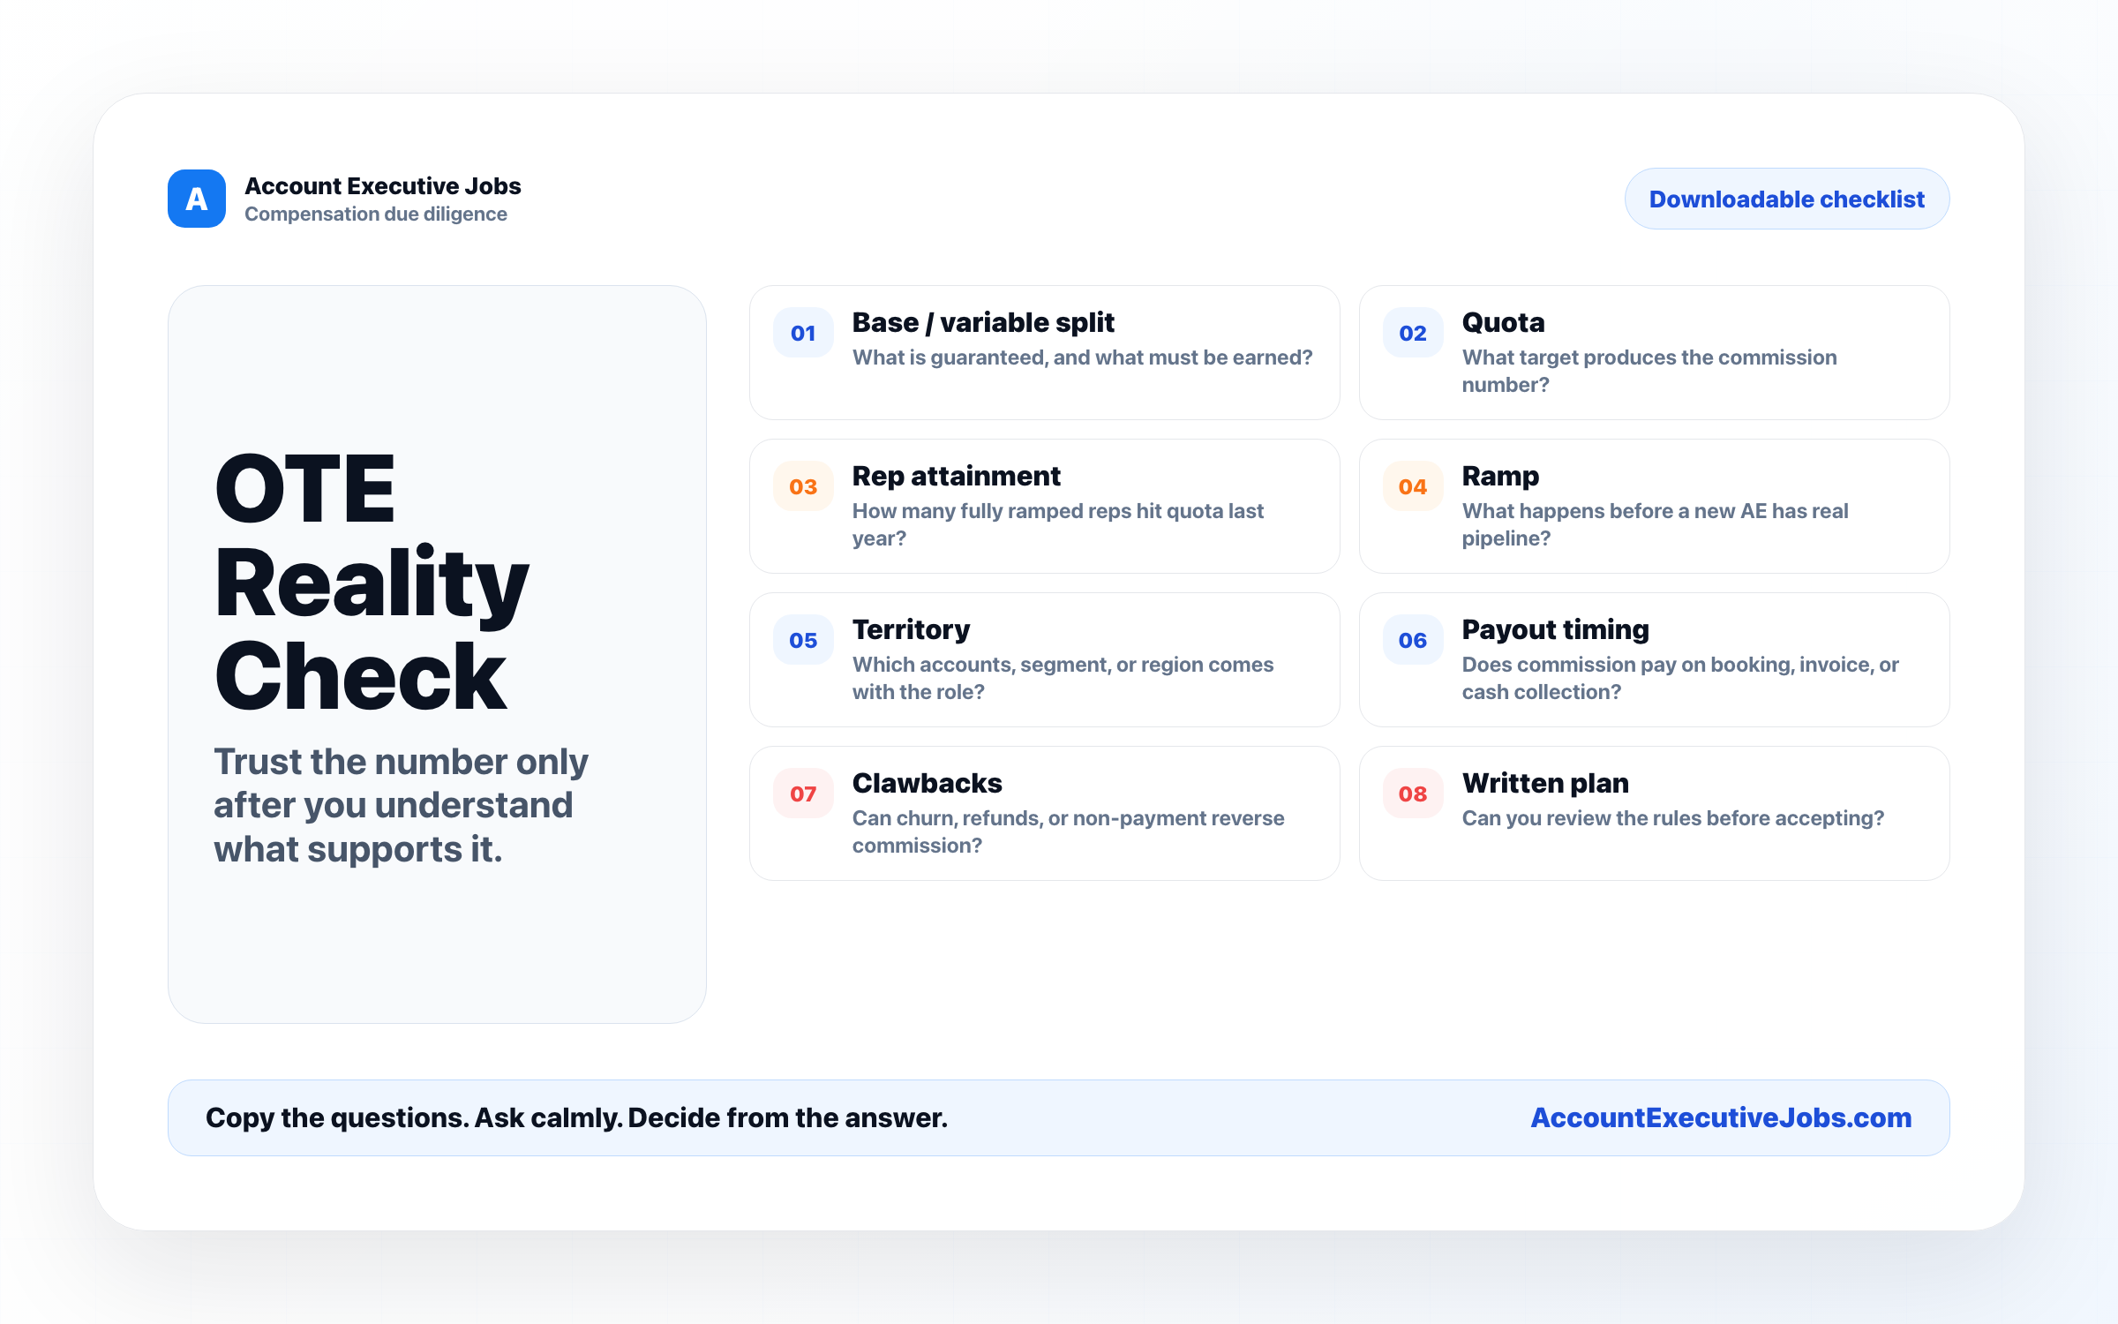

Use this reference
Read the full guide for the context behind this visual. The original illustration and its source belong together when you share it.

Notes

