

OTE Is Not Guaranteed Pay
  - Animated account executive salary explainer showing base salary plus target commission equals OTE, with quota, ramp, territory, and payout rules as the reality check.
https://accountexecutivejobs.com/blog/sales-compensation/account-executive-salary
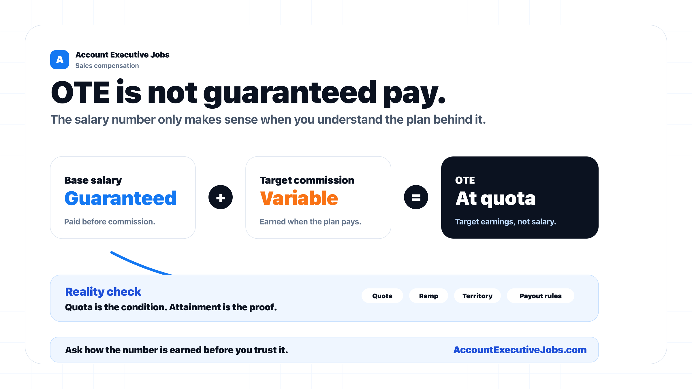

Use this reference
Read the full guide for the context behind this visual. The original illustration and its source belong together when you share it.

Notes

