

Good OTE vs Risky OTE
  - Good OTE versus risky OTE comparison for account executive salary offers.
https://accountexecutivejobs.com/blog/sales-compensation/account-executive-salary
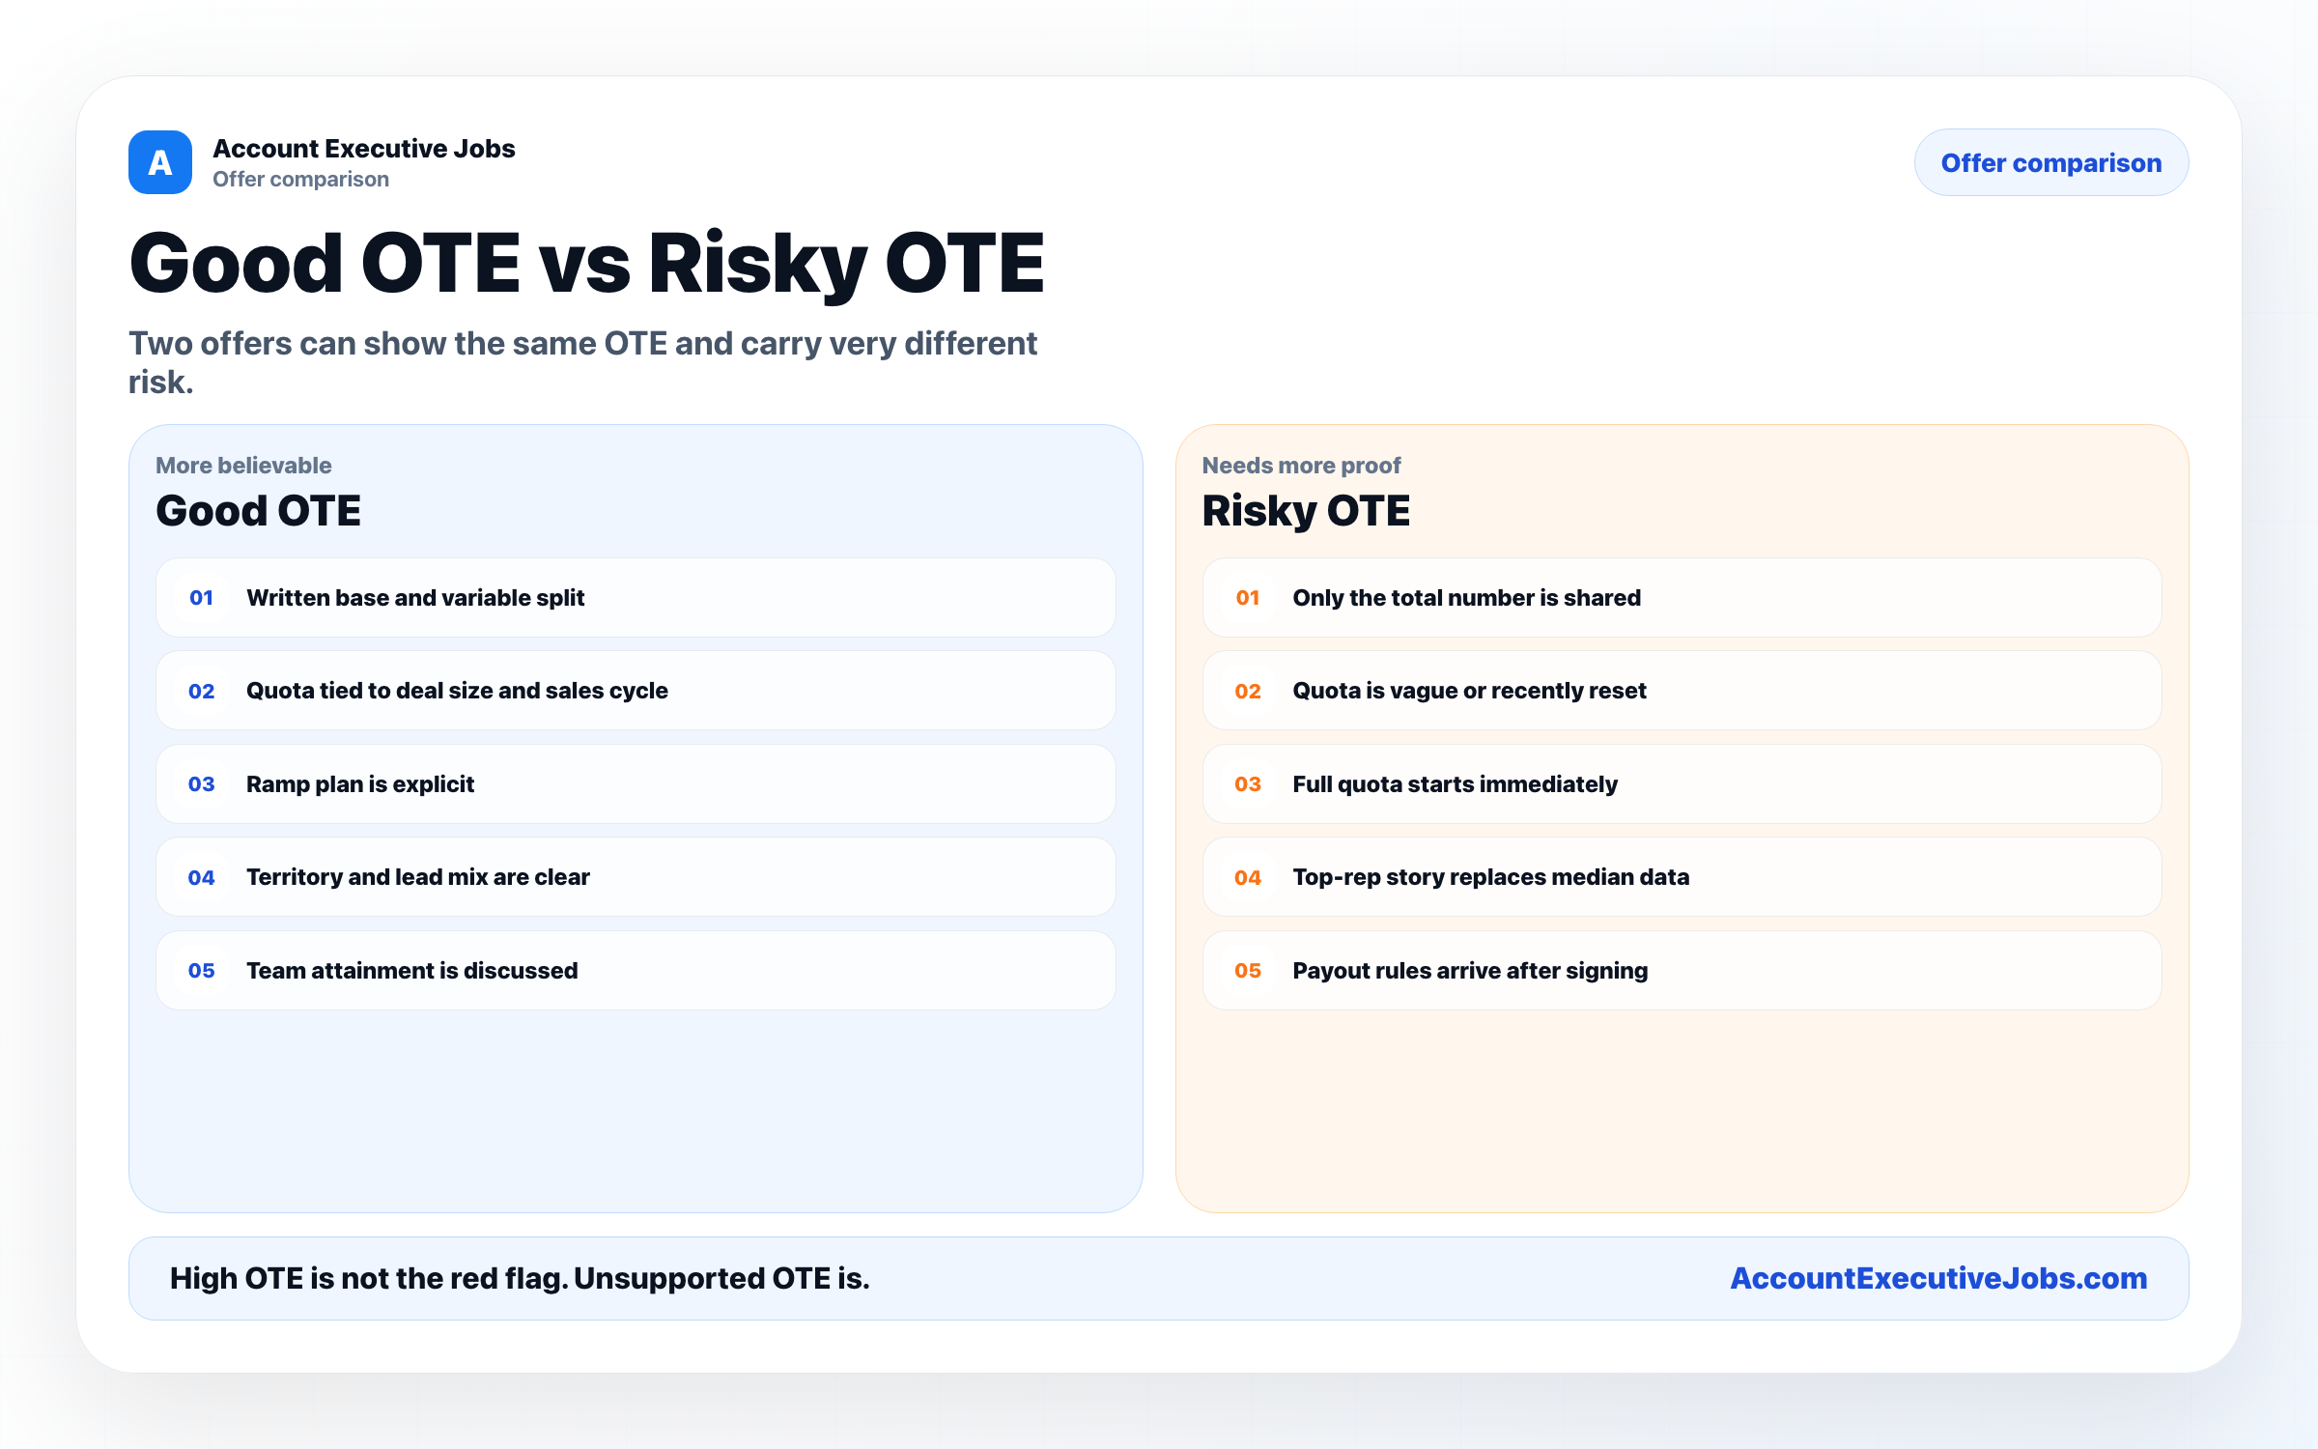

Use this reference
Read the full guide for the context behind this visual. The original illustration and its source belong together when you share it.

Notes

