

Base vs Variable vs OTE
  - Comparison of base salary, variable pay, and OTE for account executive compensation.
https://accountexecutivejobs.com/blog/sales-compensation/account-executive-salary
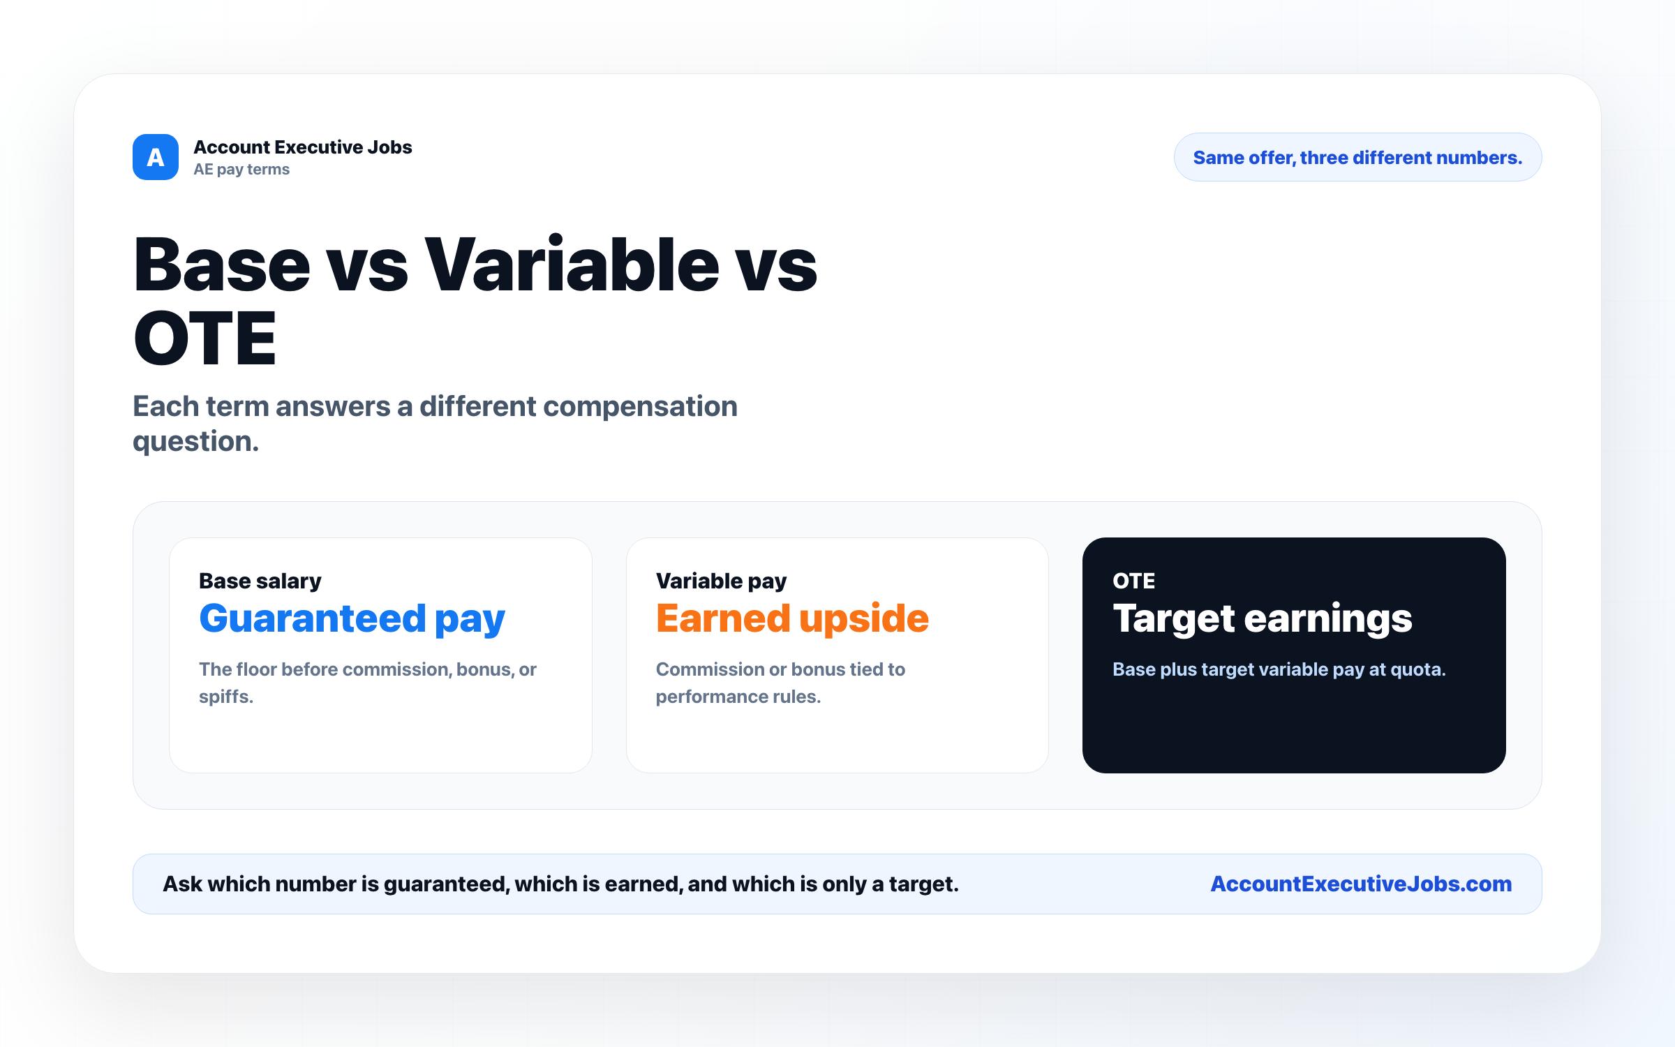

Use this reference
Read the full guide for the context behind this visual. The original illustration and its source belong together when you share it.

Notes

