

Role-Play Scorecard
  - Role-play scorecard for AE interviews covering opening, discovery, qualification, judgment, and next step.
https://accountexecutivejobs.com/blog/hiring-salespeople/account-executive-interview-questions
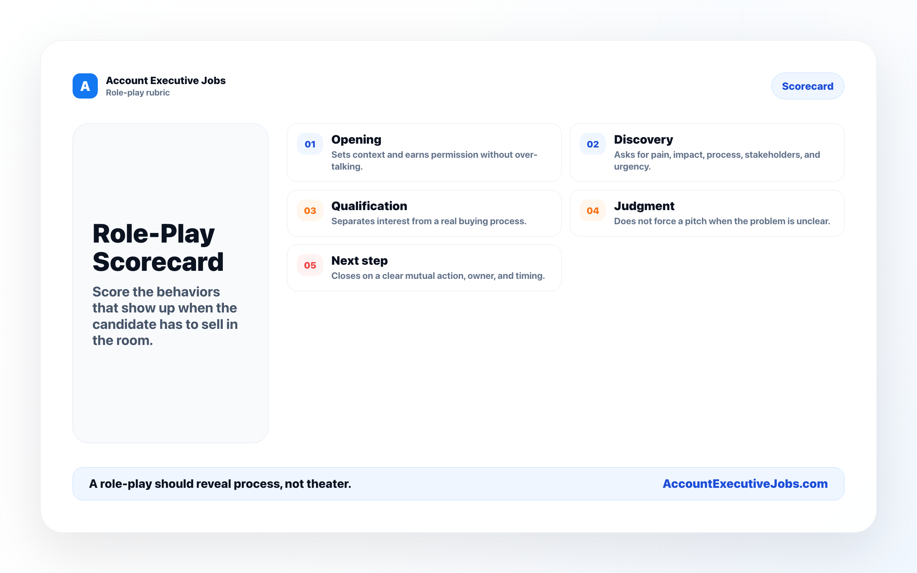

Use this reference
Read the full guide for the context behind this visual. The original illustration and its source belong together when you share it.

Notes

