

Question, Signal, Follow-Up
  - Question, signal, follow-up map for account executive interview questions.
https://accountexecutivejobs.com/blog/hiring-salespeople/account-executive-interview-questions
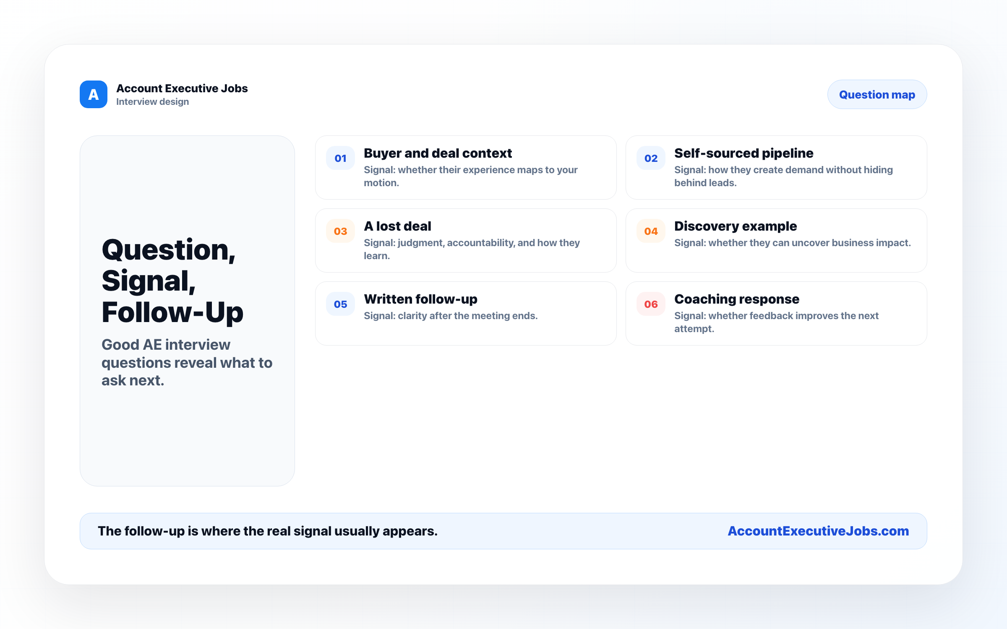

Use this reference
Read the full guide for the context behind this visual. The original illustration and its source belong together when you share it.

Notes

