

AE Interview Stage Map
  - AE interview stage map covering recruiter screen, manager interview, sales skill interview, role-play, panel, and reference check.
https://accountexecutivejobs.com/blog/hiring-salespeople/account-executive-interview-questions
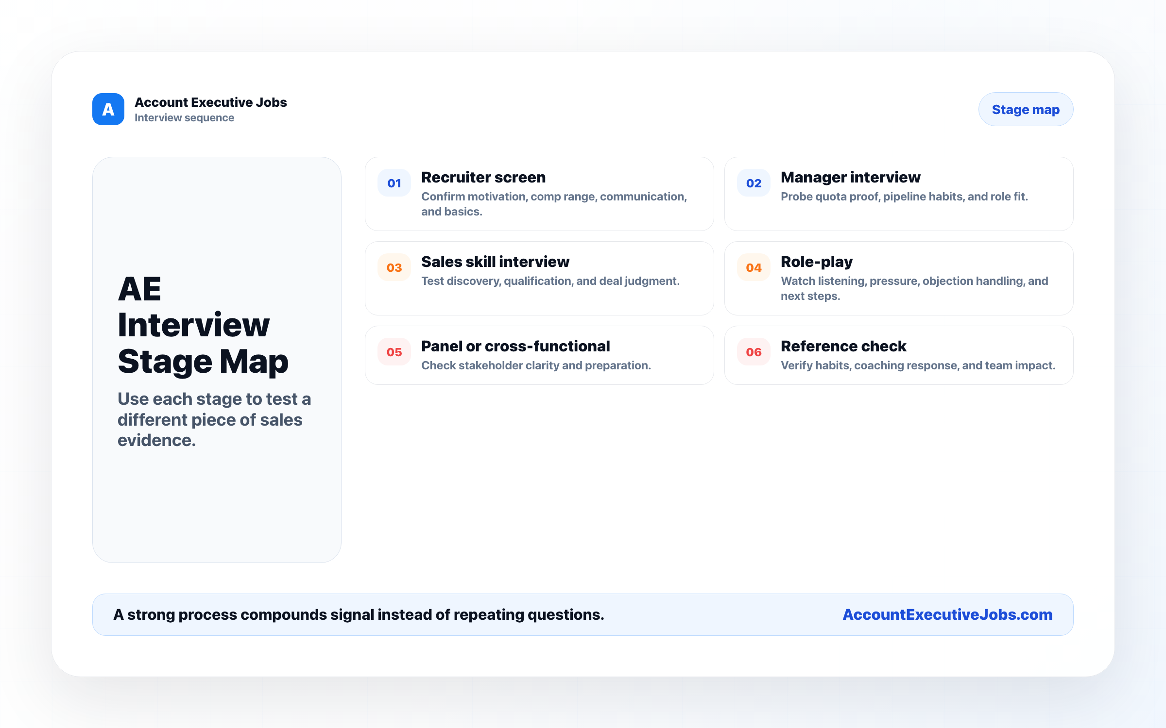

Use this reference
Read the full guide for the context behind this visual. The original illustration and its source belong together when you share it.

Notes

