

Ask Questions That Create Evidence
  - Animated infographic showing how account executive interview questions should move from question to signal to follow-up to evidence.
https://accountexecutivejobs.com/blog/hiring-salespeople/account-executive-interview-questions
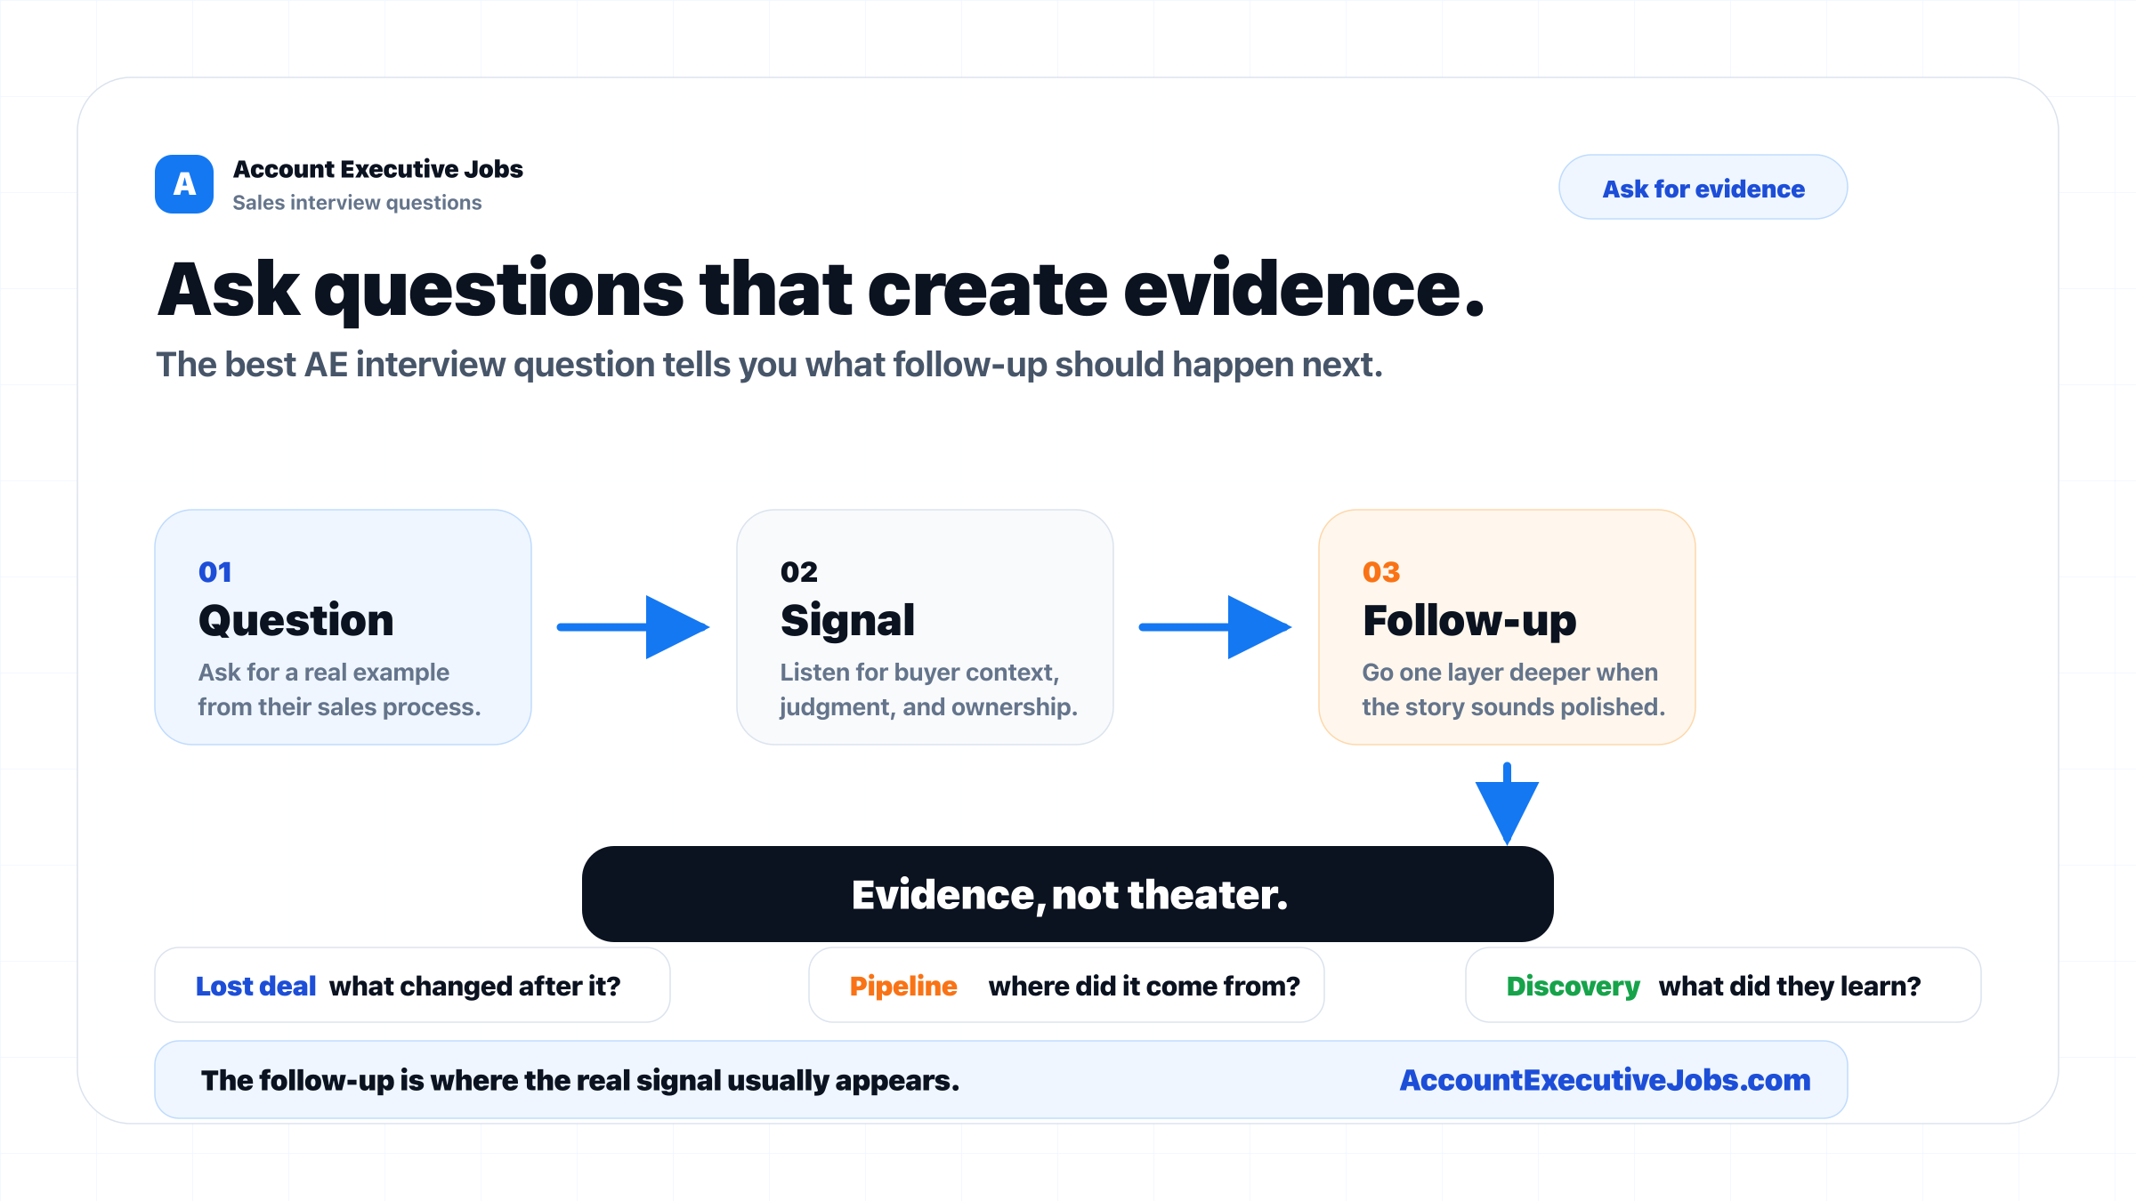

Use this reference
Read the full guide for the context behind this visual. The original illustration and its source belong together when you share it.

Notes

